HMFPS BUDGET PRESENTATION
2020/21

MARCH 10, 2020

1.0 INTRODUCTION 4
1.1 SALUTATIONS & EXPRESSIONS OF GRATITUDE 4
1.2 Broad Context 5
1.2 Graduation from IMF Programmes 8
2.0 Overview of the Economy 10
2.1 Growth for 2019/20 10
2.2 Sectoral Growth Challenges 16
2.2.1 Agriculture 16
2.2.2 Mining Sector 17
2.3 Comparing Growth Across Periods 18
2.4 Analysing Impact of Mining on Growth 19
2.5 Historic Period of Consecutive Quarterly Growth 19
2.6 Further Historical Perspective on Growth 20
2.7 Fiscal Policy and Growth 21
2.8 Growth for 2020/21 26
2.9 Revenue Performance 26
2.10 Capital Expenditure Execution 27
2.11 Employment 28
2.12 Employment Gender Gap 29
2.13 Reconciling Record Employment and Low Growth 30
2.13 Debt 31
2.14 Credit Rating 31
2.15 Monetary Policy 32
2.16 Inflation 34
2.17 The Consumer Price Index 34
2.18 Foreign Exchange 35
2.19 Current Account 36
3.0 Highlights of Other Achievements 37
3.1 Tax Cuts Made Permanent 37
3.2 New Procurement Regime 38
3.3 Pension Fund Modernisation 39
3.4 Public Body Governance 40
3.5 Customs Act 40
3.6 Micro-credit Act tabled 40
3.7 BOJ Modernisation 41
3.8 Fiscal Council 41
3.9 Wigton IPO 41
3.10 TransJamaica IPO 42
3.11 Public Sector Transformation 44
3.11.1 Rationalisation of Public Bodies 44
3.11.2 Compensation Management 44
3.11.3 MyHR+ - the integrated HR and Payroll system 44
4.0 Strategic Initiatives 45
4.1 Disaster Risk Financing 45
4.1.2 Catastrophe Bond 47
4.2 AML/CFT Framework 48
4.3 Open Government Partnership 49
4.4 Jamaica Public Investment Map 49
4.4.1 How does the Platform Work? 50
4.5 Financial Literacy 51
4.6 Student Loan Policies 51
5.0 OVERVIEW OF THE GOVERNMENT’s 2020/21 EXPENDITURE BUDGET 52
Debt Service expenditure $287.8 billion 53
5.1 Non-Debt Recurrent Expenditure 53
5.2 Capital Expenditure – Investing in Public Services 53
5.2.1 Investing in Physical Infrastructure 54
5.2.2 Investing in Social Infrastructure 55
5.2.2.1 Investing in the Development and Expansion of Hospitals 55
5.2.2.2 Investing in Education 56
5.2.2.3 Investing in Social Services 57
5.2.3 Investing in National Security Infrastructure 57
5.2.4 Investing in Economic Infrastructure 59
6.0 SOCIAL PROTECTION 60
6.1 Social Pension for the Elderly 62
6.2 Social Intervention Public Work Programmes 64
6.3 Gully Intervention Programme 65
6.4 Gully Intervention Maintenance Program 65
7.0 Marcus Garvey Scholarships 66
9.0 Other Expenditure 68
9.1 Non-Debt Below-the-line Expenditure 68
9.2 Debt Service 68
10.0 REVENUE MEASURES 69

1.0 INTRODUCTION

1.1 SALUTATIONS & EXPRESSIONS OF GRATITUDE
Mr. Speaker, I begin by thanking Almighty God, from whom all blessings flow.
Great is thy faithfulness. Great is thy mercy and thy loving kindness.

Mr. Speaker this is a demanding job and one I could not do without the support of family, friends and colleagues.

To the Councillors and Executive of the North Western St Andrew constituency organisation, many of whom are here today thank you for your steadfast support. Thank you for working assiduously with me to advance the interest of the citizens of North West St Andrew.

Mr. Speaker it is an honour to serve in this parliament and I thank my parliamentary colleagues for their support and encouragement. I thank the staff of the House of Parliament who are very professional and courteous and with whom I enjoy interacting.

I thank Prime Minister, the Most Honourable Andrew Holness, for his confidence and support. Prime Minister Holness has consistently shown the courage to make and support the decisions required to move Jamaica in the right direction. He is the leader for our times.

Mr Speaker, I thank my Cabinet colleagues for their support and for a working environment characterized by teamwork, cohesiveness and shared vision.

Jamaica benefits from a first class team at the Ministry of Finance, and I thank them for their dedication and commitment. I thank the Financial Secretary Darlene Morrison and her team at the Ministry as well as my advisory staff. I also thank the administrative and ancillary staff in my office and the security staff assigned to me who always go beyond the call of duty.

I also would like to thank the Board, management and staff of the Bank of Jamaica (BOJ) and the Planning Institute of Jamaica (PIOJ), critical institutions that play a key role in Jamaica’s economy.

Again Mr Speaker, most of all I would like to thank my family, who now share me with North West St Andrew and by extension Jamaica. To my brothers and sister, thank you. To my wife and children, thank you for your love and support. You help me maintain balance and perspective and without you I could not do what I do. I am indebted to my parents, the late Justice Neville Clarke and Mrs Mary Clarke, who is here, for imparting values I cherish in our upbringing.

1.2 Broad Context
Mr. Speaker, Jamaica is among a small handful of countries in the world that can proudly boast of having a continuous, unbroken, liberal democratic tradition for over 75 years, 18 Pre-independence years and 57 Post - Independence years.

Importantly, our democracy is not simply “ballot box democracy”. Many countries in the world practice an illiberal form of democracy, which only works on election day. Our democracy is deep and it is enshrined in liberal traditions and institutions. (To be clear, I am using the word liberal is in the sense of classical liberalism as opposed to liberal in the modern American political context.)

The freedom of the press in Jamaica has ranked in the top ten in the world for decades. Think about that Mr. Speaker. Those in this chamber are acutely aware of how free the press is in Jamaica.

We enjoy genuine separation of powers with different and co-equal branches of government that are independent of each other – the legislature, the executive and the judiciary. And we have enjoyed this separation for more than 75 years.

We operate under the rule of law and we are an open society where the rights of private property are enshrined and citizens enjoy protection of their human rights, their civil rights and their political freedoms. Freedom of speech is deeply embedded in our way of life. A few years ago we enshrined these rights by way of a constitutional amendment that inserted the Charter of Rights and Freedoms into the Constitution.

Mr. Speaker for the past 75 years, Jamaica has enjoyed universal adult suffrage where every single adult has had the right to vote.

This is a longer period than, for example, Australia, Canada, Chile, Portgual, South Korea, South Africa and many other far wealthier nations than ours for whom segments of their populations have been voting in general elections for a far shorter period of time than Jamaicans have.

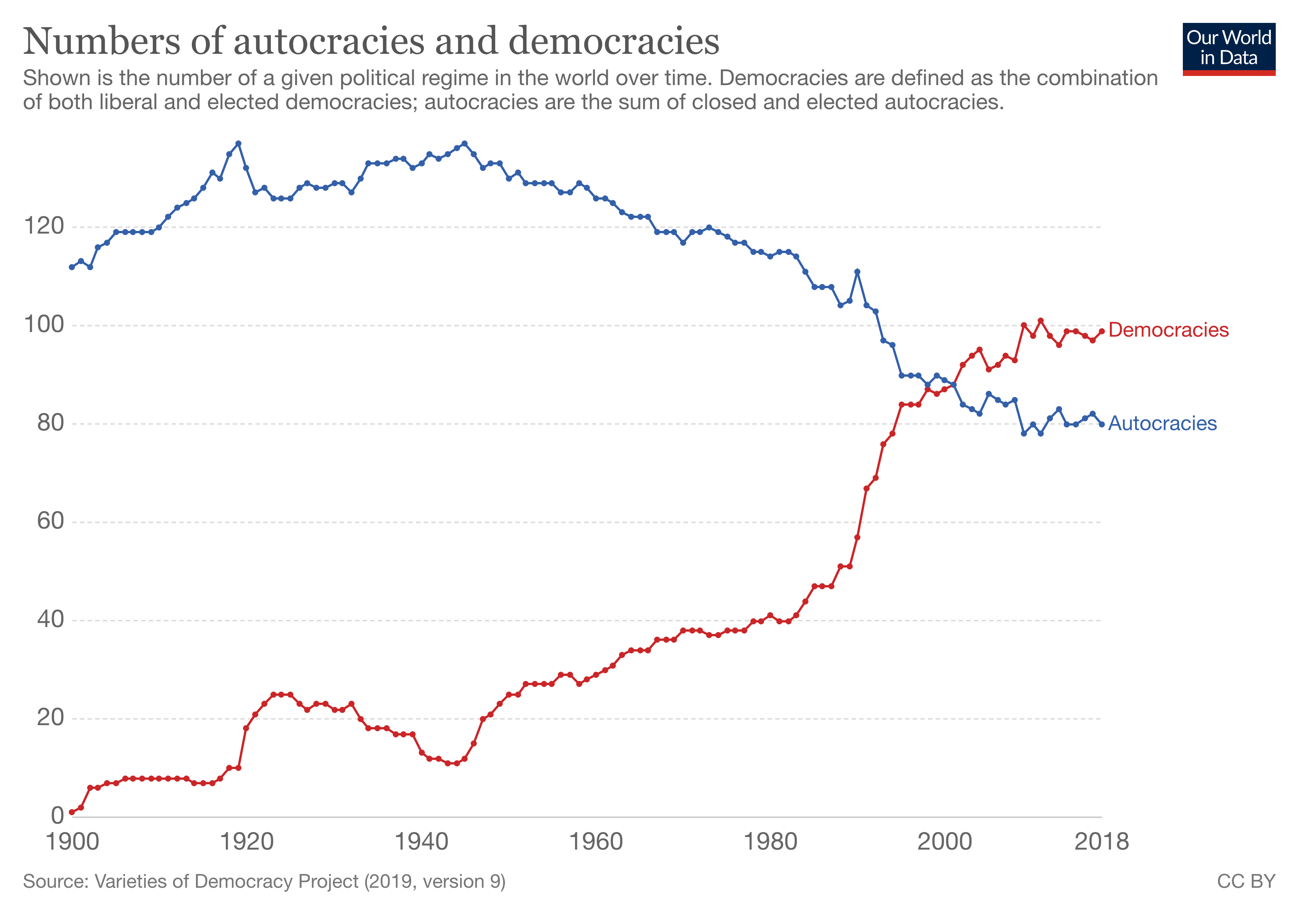

Mr. Speaker the world knows of few examples, if any, of countries that have climbed the ladder of economic success, all the way from developing to developed, with a purely liberal democratic model. Virtually all developed and advanced countries today experienced institutional illiberality of one form or another on their path to economic success. Virtually all, on their path to advanced status, have either excluded or even subjugated segments of their populations, in some cases restricting freedom itself. Others, on the path to economic success, have had periods characterised by restrictions on political and/or civil rights, restriction on freedom of the press, freedom of speech and other freedoms.

Mr. Speaker, Jamaica is firmly and immutably entrenched on the path of freedom, rooted in 75 years of liberal democratic thinking and culture. The point is not to question that.

The point, Mr. Speaker, is that we need to be conscious and aware of the fact that we are attempting to do that which has not yet been done – to grow and develop as a nation, from developing to developed, within a liberal democratic model, a path for which no (or little) precedent of success yet exists.

Our understanding of ourselves would be a lot healthier, Mr. Speaker and our interactions more productive if we operated with consciousness of this simple fact.

Instead of engaging in endless self-flagellation as a people, we would exude greater depth of pride, fully cognizant of the greatness of our ambition as a people even as we strive to implement and improve.

For liberal democracy, as you will no doubt agree, even if it requires some reflection, is an expensive form of government Mr. Speaker. The private and public institutions that provide, express, safeguard and guarantee our political and economic freedoms require significant human and financial resources to operate effectively.

As a matter of historical fact, for many advanced countries, their political model evolved in step with their economic capacity to sustain that model. They became more and more liberal, more and more democratic, more and more free as they grew in wealth as nations.

It is to the audacious disposition and the eternal optimism of the Jamaican spirit that explains our path, which differs. Our founders, who agitated for universal adult suffrage 75 years ago, and in whose footsteps we walk, were unequivocal that Jamaica views freedom, in all its forms, as a value in itself and essential for all other values to flourish.

It is for this reason, that for our model to be sustained over generations, it has to be manifestly evident, through experience that our political and liberal traditions consistently deliver – and deliver handsomely – for the Jamaican people.

As I said earlier, political freedoms represent a value itself. However, people cannot eat “political freedom”.

It is therefore, necessary Mr. Speaker that the dividends of our political freedoms ought to provide the capital with which our economic prosperity and our economic independence are built.

Our political freedoms must translate into economic freedom and material benefit, improved well-being, and improved public service for all.

Political competition, which is central to our liberal democratic model, must, ultimately, be in service of the sustainable material progress of our people.

However, until recently, our economic history over much of the last fifty years has not delivered that. It has largely been characterized by systemic economic instability with cycles of economic progress followed by economic reversal. As a result, the material condition of our people stagnated. Per capita GDP, one measure of material attainment, was constant for two decades while many of our neighbours surged ahead.

To deliver for the people of Jamaica requires us to consistently be moving forward, Mr. Speaker. The steps may be large at times and other times small. But they must always be moving us in the right direction.

In recent times, Jamaica has made significant progress but vulnerabilities exist and much remains to be done. We still have a long way to go.

For our model to be sustained, the people must know, from their own experiences, that we are committed to moving forward, in the right direction, and moreover, that as we make progress, they too, are sharing in the gains. This is of critical importance.

These gains, Mr. Speaker, are best shared with all by investing in public services, improving conditions for business and employment to flourish, strengthening the social safety net, and preserving and increasing spending power.

This reflection is always necessary Mr. Speaker. We must be deliberate and strategic in what we do, ever conscious of the context in which we operate, because as to paraphrase Marcus Garvey, “Chance has never satisfied the hope of a suffering people.”

Today, Mr. Speaker I will present a budget that is strategically focused on moving forward, in the right direction, consistently, and where the fruits of our collective effort are shared.

A budget, Mr. Speaker that demonstrates that our political model is working and that our political freedoms, and our liberal democratic traditions are ultimately in service of the sustainable increase in the material well-being of the Jamaican people.

1.2 Graduation from IMF Programmes

In November 2019, Jamaica successfully completed the three-year Precautionary Stand-By Arrangement with the IMF. Over the course of this programme, under the Andrew Holness government, all structural benchmarks were met, all performance criteria were satisfied, and all quantitative targets were exceeded.

Mr. Speaker, Jamaica is moving in the right direction.

The completion of this agreement with the Fund has allowed Jamaica to exit a programme relationship with the IMF.

The achievements under this programme, and under Extended Fund Facility (EFF) that preceded it, have caught the attention of the world for all the right reasons and Jamaica has much of which we can be very proud.

I want to take a moment to recognize the work done by the prior administration and in particular former Prime Minister the Most Hon. Portia Simpson-Miller and former Finance Minister Hon. Dr. Peter Phillips in doggedly pursuing the EFF and rallying Jamaicans around it.

Let us recognize the significant efforts and contributions of former Prime Minister the Most Hon. Bruce Golding and former Finance Minister, and Man a Yaad, Hon. Audley Shaw. Though difficulties were encountered in the 2010 agreement, they were the first elected officials to act decisively to address the problem of unsustainably high debt.

Let us recognize, Prime Minister Holness and this administration for the maturity and resolve shown to entrench reforms, modernize institutions, and implement difficult new reforms; including required and necessary monetary reforms and to navigate Jamaica toward a successful exit from a programme relationship with the IMF.

Let us recognize Ministry of Finance officials, current and former Financial Secretaries, public sector unions, the Bank of Jamaica, and former Governor Bryan Wynter, EPOC, and the role played by its co-chairs Richard Byles and Keith Duncan.

And let us recognize the critical role played by the media.

Most importantly, Mr. Speaker, let us recognize the Jamaican people. This success is your success, the people of Jamaica.

Along with 188 other countries around the world we are a voting member of the IMF. As such, Jamaica, like all other member states, remains subject to the IMF’s annual review as has been the case since we joined the Fund in 1963.

Mr. Speaker, quite often even countries that are well run need to seek the support of the IMF as external conditions change. That is the reason for the IMF’s existence. However, Mr. Speaker, we owe it to ourselves and to future generations to resolve that we will never, ever, again put ourselves in a position where we place cripplingly high and unsustainable levels of debt on the backs of the Jamaican people.

Economic Stability

Mr. Speaker, macroeconomic stability is necessary for sustainable long-term growth and development, although we know it is not sufficient. It is necessary because it provides the economy flexibility and policy space to absorb and respond to unexpected economic shocks without disrupting day-to-day activity.

Sadly, Mr. Speaker, for nearly 50 years, across 16 IMF programmes, macro-economic stability has eluded Jamaica.

Today—in significant part as a result of the hard work and tremendous sacrifices of the Jamaican people—we concurrently enjoy the following:

- First, fiscal sustainability – debt is under a firm downward trajectory and budgets over the medium term can be financed without altering that trajectory

- Second, external sustainability – we have sufficient reserves in the central bank to provide a buffer against unexpected external shocks

- Third, price stability – we have enjoyed 5 years of low, stable, and predictable inflation

- And, fourth, financial stability – loan loss reserves in our banks are adequate and our banking system is properly capitalized.

These four pillars together provide the foundation of macro-economic stability.

We have never before experienced all four of these critical pillars at the same time, not in the 1970’s, not in the 1980’s, not in the 1990’s and not in the 2000’s. Today, however, Mr. Speaker, we are finally experiencing the critical macro-economic stability that has so painfully eluded us for far too long.

That is what makes this time so significant and such a time of tremendous opportunity.

With a strong platform of macro-economic stability, Jamaica is moving in the right direction.

To be sure, vulnerabilities remain due in part, to levels of debt that remain high. But the stability we have achieved is hard-earned and so it is our duty, Mr. Speaker, to preserve, institutionalize, and protect our collective achievement of hitherto elusive macro-economic stability.

We now have the historic prospect of leveraging this economic stability, without compromising it, to build a new Jamaica with economic opportunity for all.

2.0 Overview of the Economy

I would like to turn my attention to economic growth, Mr. Speaker.

2.1 Growth for 2019/20
Let me start with the fact that the Government is dissatisfied with the level of economic growth of 0.6% likely to be recorded this for year 2019/20. The Prime Minister is dissatisfied, the Cabinet is dissatisfied, and I am dissatisfied.
In the previous financial year, Jamaica grew at an annual rate of 2%, the highest rate of economic growth in 12 years. At the start of this financial year, the Government projected economic growth of 1.5 which factored in a slowdown at the JISCO/Alpart alumina plant in St. Elizabeth.
Mr Speaker, during the course of the year we were disappointed to learn from JISCO that they would be closing their plant for 24 months for repairs and upgrading.
Given the significant financial value of the output of the JISCO/Alpart plant and the weight of its contribution to economic growth, its closure led to an immediate downward revision in growth for this year.
It should be clear, Mr Speaker, that had this single event not occurred, it is likely that annual growth targets would have been met. It should also be noted, Mr. Speaker, that there were several external factors outside the control of Government that led to this decision by JISCO, what is known as an external economic shock.
Mr Speaker, the closure of JISCO meant that the mining sector declined by 17.6% in the third quarter and further declined by 38.7% in the fourth December quarter.

The important news is that, despite this significant setback and blow to our mining sector, the economy still experienced growth. This only occurred, Mr. Speaker, because other sectors of the economy are bubbling up.
For example, Mr. Speaker, the tourism sector grew by 7.3% in the first quarter, 5.8% in the second quarter, 2.5% in the third quarter and is projected to grow by 3.5% in the fourth quarter, and has grown for all 16 quarters of this administration.

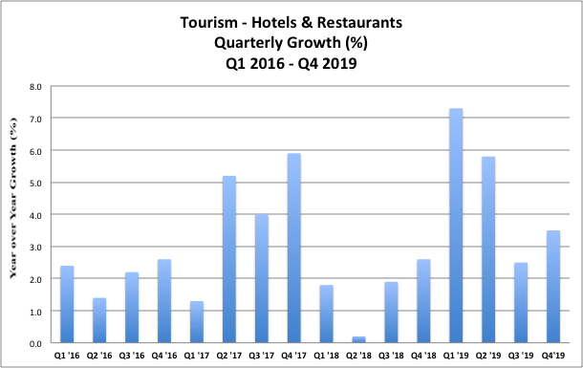

The manufacturing sector, Mr. Speaker, grew by 3.2% in the second quarter, 4.9% in the third quarter of 2019, is projected to grow by 0.4% in the third quarter, and has grown for 13 out of 16 quarters of this administration.
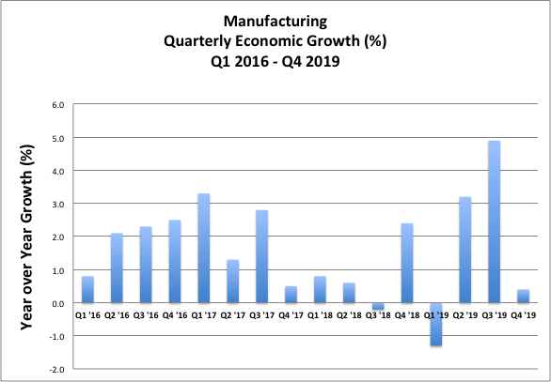

Mr. Speaker, the transport, storage & communication sectors have grown for every one of the 16 sectors of this administration thus far.

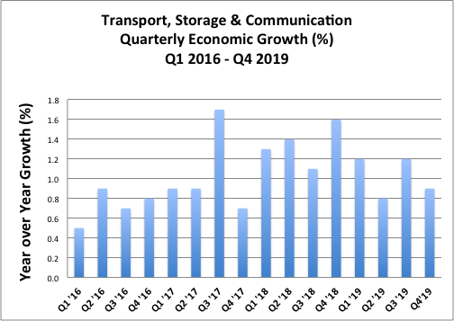

Mr. Speaker, the Real Estate Renting and Business Activities sectors have grown for each of the 16 sectors of this administration thus far.

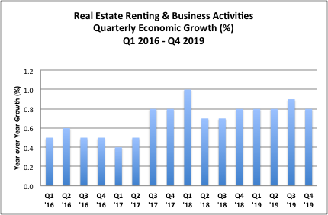

Mr. Speaker the Other Services Sector has grown for all 16 quarters of this administration thus far.

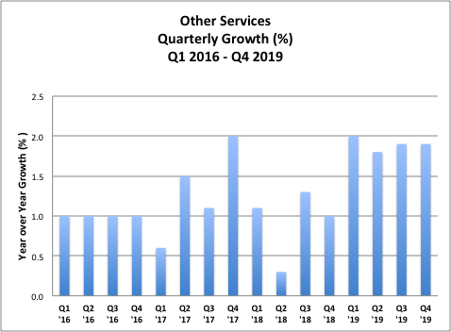

The wholesale & retail/repairs/installation of machinery & equipment sectors have grown for every quarter of this administration with only one exception.

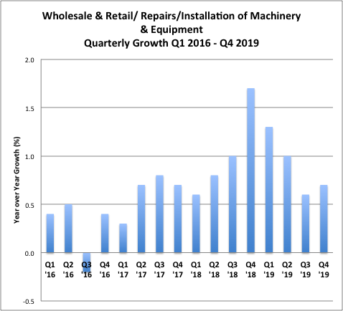

The construction sector, Mr Speaker, is comprised of both private construction and government construction. Private construction is booming, quite evidently. Not in over 30 years has there been so much construction happening at the same time.

However, government construction is lower than the previous year. You will recall, Mr Speaker, that the quarterly growth of construction in the previous financial year exceeded 3% in two quarters and exceeded and 4% in the other two quarters, boosted by approximately $28 billion spent on MIDP projects.

This public investment expenditure fell this year, and although public body capital expenditure was increased, the delays in the South Coast Highway Improvement project resulted in a year-over-year decline in overall government construction.

However, Mr Speaker this will be addressed. We will get to the numbers in our infrastructure programme shortly but suffice it to say we expect construction to return to growth in 2020/21.

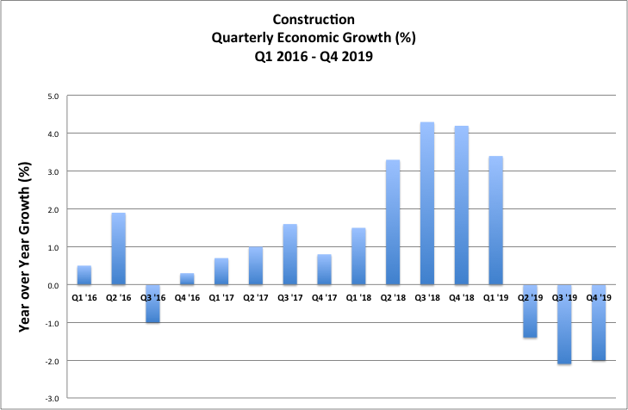

2.2 Sectoral Growth Challenges

Notwithstanding the bubbling up of those aforementioned sectors, Mr. Speaker, we do have challenges with growth in two sectors in particular which together have conspired to overshadow the progress being made in the other sectors of the economy.

2.2.1 Agriculture

The first is Agriculture. This sector has been affected by either drought or excess rain for much of the past two years.

Later, I will provide an overview of the budgetary allocations to address the challenges we have been having and Minister Shaw will provide additional details in his presentation.

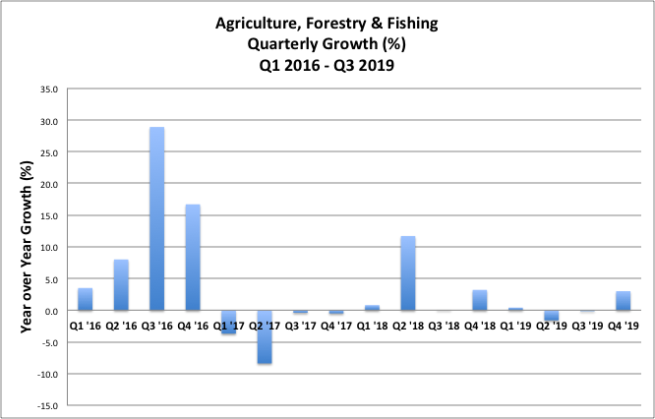

2.2.2 Mining Sector

The mining sector has exhibited wild swings in output, oscillating between double digit decline and double digit growth that has overshadowed overall growth outcomes and masked much of what is happening in the Jamaican economy.

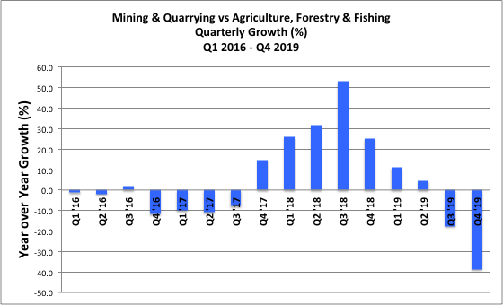

2.3 Comparing Growth Across Periods

Mr. Speaker, it is important to point out certain other facts.

Just to be abundantly clear Mr Speaker, even with this steep 17.6% and 38.7% decline in the mining sector this year, as a matter of fact, the average quarterly growth of the last four years 2016 - 2019 is four times the average quarterly economic growth of the previous four years 2012 – 2016 and three times the average quarterly growth over the previous nineteen years from 1997 when we started measuring growth quarterly up to the end of 2015

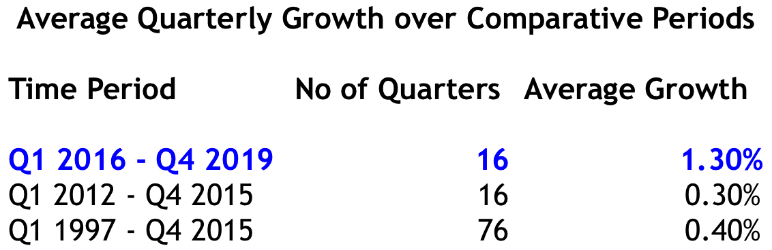

Average quarterly growth of 1.3% might be slower than we want Mr. Speaker but it is a considerable improvement on where we are coming from and it is moving in the right direction.

Mr. Speaker, Jamaica is moving in the right direction.

We can look at the annual data as well Mr. Speaker. The average annual growth for the four fiscal years 2016/17 – 2019/20 (using PIOJ forecast of 0.6% for 2019/20) is three times the annual growth for the previous four year period 2012/13 – 2015/16 and also three times the annual growth rate for the 19 years prior to 2016.

Again, just putting the facts out there Mr Speaker. Again average annual growth of 1.2% might be slower than we want but it is a considerable improvement on where we are coming from.

That Mr. Speaker is moving in the right direction. We are moving forward.

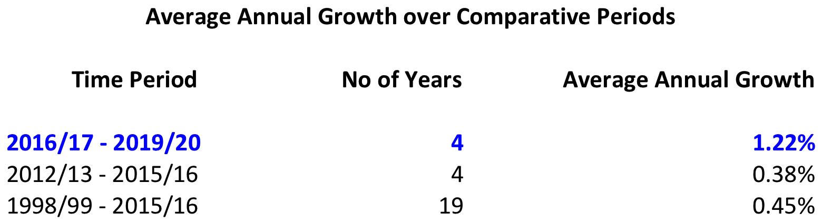

2.4 Analysing Impact of Mining on Growth

In addition, if one strips out mining, the data reveal that Jamaica’s growth would have been much smoother over the last five years, with less volatility.
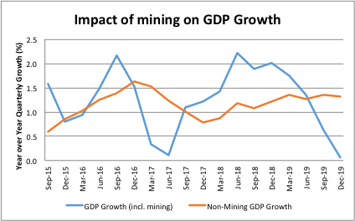

2.5 Historic Period of Consecutive Quarterly Growth
Mr Speaker, despite the large volatility in our mining sector, Mr Speaker, Jamaica is expected to register 20 consecutive periods of quarterly economic growth based on PIOJ forecasts for the December 2019 quarter.
This is, by far, the longest period of quarterly economic expansion since Jamaica started measuring growth quarterly in 1997.

Jamaica has experienced quarterly growth every single quarter for the last five years.

Mr. Speaker, Jamaica is moving in the right direction.

2.6 Further Historical Perspective on Growth

Mr. Speaker, this historic stretch of quarterly growth is quite significant. It does not invalidate commentary on lower growth outcomes for this financial year. However, it is of historical and economic significance that, after all is said and done, after all the chips are in, Jamaica has had uninterrupted quarterly growth expansion for five consecutive years.

To understand the significance, one just has to recall that the previous longest stretch of consecutive quarterly economic growth was only nine (9) quarters or just over two years, between Q3 2002 and Q3 2004 and again between Q3 2005 and Q3 2007.

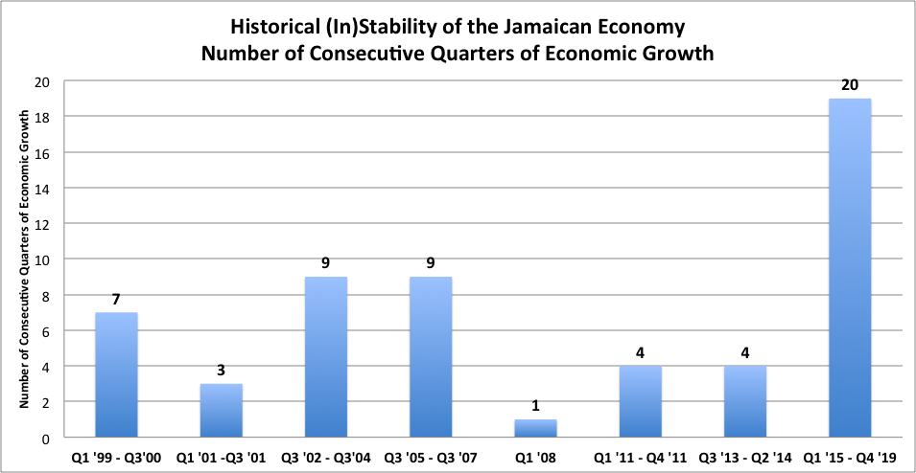

Consider also that over the period beginning in 1997, when we started measuring growth quarterly, and ending prior to the beginning of this five year stretch of unbroken quarterly growth, Jamaica experienced a total of 33 quarters of year-over-year economic decline and 37 quarters of year-over-year economic growth.

What we have experienced prior to now, in other words, is “forward” quickly followed by “reverse” with the net effect that we stagnated as a country for so long. Mr Speaker, per capita GDP measured over 20 years did not change.

This historical macro-economic instability of the Jamaican economy, characterized by many swings between growth and decline, is exactly the opposite of what we want for reasons mentioned earlier.

Now, Mr Speaker, at a minimum at least we just moving forward, and forward, and forward, which, after all, is the right direction.

Today, Mr Speaker, PIOJ reports that production levels in Jamaica are at the highest levels they have been in Jamaica’s history and per capita GDP is also higher than it has ever been.

Mr. Speaker, Jamaica is moving in the right direction.

Finally, Mr. Speaker, Jamaica’s economic growth over the past four years has been higher than the average economic growth in all of Latin America and the Caribbean in each of these years. Commodity price weakness and global trade tensions have been impacting growth not only in Jamaica, but across the region.

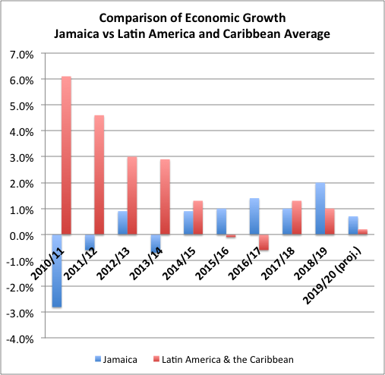

2.7 Fiscal Policy and Growth

Mr Speaker, levels of consumption and investment in an economy impact GDP.

Fiscal policy thereby has the potential to boost the size of the economy, and therefore economic growth, by boosting consumption and boosting investment.

However, life isn’t always that easy. If fiscal policy is used to boost consumption and investment in a way that is unsustainable, or that leads to high inflation and instability, any growth it leads to will be temporary, will not be sustained, and we would be back to the “forward and reverse” cycle that plagued our country for too long.

Now, Mr Speaker, sometimes those who support the Opposition get defensive when you discuss the performance of the economy over the time of their stewardship. Like all periods in the past, however, this history belongs to all of us and we all benefit from sincere analysis, presented from varying perspectives over time. Indeed this time too will be analysed by future generations. That is how we move forward as a society. We learn from our own history. It is all about moving forward, Mr Speaker.

I give you as an example the period 2002 to 2004

Take a look at the quarterly year-on-year growth:

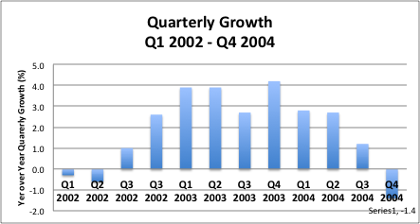

Look on the deficit spending that accompanied it:

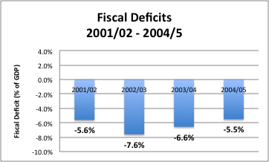

And the debt that accumulated:

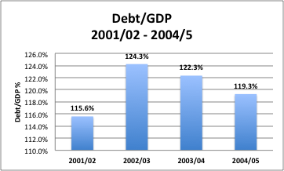

And how much of GDP this debt cost to service:

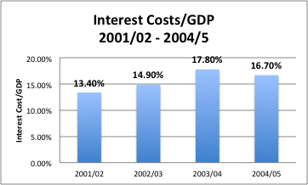

and how much of tax revenue interest consumed:

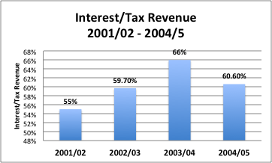

and the inflation that resulted:

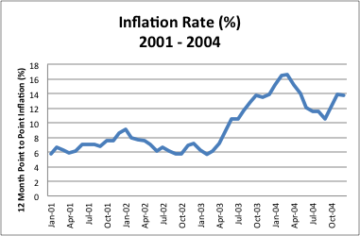

and the high unemployment that we endured:

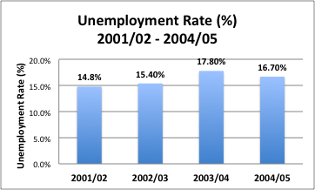

We have all lived through what this high debt, high inflation, and macro-economic instability cost us as a country. We used over 60 cents out of every dollar of tax revenue just to service the interest on our debt – not including the principal. High debt impoverishes us as it creates a huge fixed burden that leaves us completely vulnerable. This was unsustainable and we all know how this played out later. We were caught with unsustainable debt in a global crisis with no policy space.

I share this not to make a political point. After all, let me emphasise that deficit spending was not limited to those years. We engaged in large, untamed deficit spending for almost 20 years with the only thing to show for it was high debt, high inflation, and high unemployment for most of the period.

I zoned in on 2002 – 2004 because we also had quarterly growth then, simply to say that, if growth was all that we wanted, using fiscal policy to achieve it would be relatively easy. We would just increase spending or cut taxes without regard to any other considerations.

However, growth is not all we want. We want macro-economic stability, we want growth, we want jobs, and we want debt reduction all at the same time.

So whatever we do with fiscal policy in the service of higher levels of economic growth has to be sustainable, it has to preserve macro-economic stability, and it has to continue reducing our debt.

Fiscal and monetary policy, are the two main macro-economic policy tools that can be used to influence the economy. Monetary policy – the setting of interest rates and liquidity conditions – has certainly been deployed to accelerate the level of economic activity with success. I speak about that later. However, with the BOJ policy interest rate at a historically low 0.5%, monetary policy space is more limited than before.

Mr. Speaker, it is time for fiscal policy to respond, but to do so in a manner that preserves Jamaica’s hard-earned gains. That preserves jobs, preserves macro-economic stability, preserves low inflation, and preserves the steady reduction in the debt burden and interest costs.

2.8 Growth for 2020/21

Mr Speaker in the Fiscal Policy Paper laid in the House on February 11, Government is forecasting growth of 1.2% for the fiscal year 2020/21.

However, in light of the emerging global health threat this growth may have to be officially revised downwards. Preliminary, but not yet official expectations, are for growth to be in the region of 0.7%. In the near term it is possible for sectors such as tourism to be negatively affected with a rebound in later quarters.

Later in the presentation I will return to this downside scenario analysis.

2.9 Revenue Performance

For the 2019/20 financial year which comes to a close in three weeks, revenues have performed well against budget.

For the nine months to December 2019, tax revenue receipts were up 2.7% over budget and 6.7% over the similar period in Financial Year 2018/19.

Furthermore, Mr. Speaker, though we started the year with an unprecedented and historic $14 billion tax give back, tax revenues are now projected to end the year at $577 billion which is just $2 billion short of the original budget level of $579 billion prior to the tax give-back.

That, Mr. Speaker, is a sure indication that despite our challenges, Jamaica is moving in the right direction.

It is all the more significant as it occurred in the context of a downward revision to growth from the original 1.5% for the year to 0.6%.

Most indicative of buoyancy in the economy is that revenue from both corporate income tax and PAYE registered large increases over the budget and over prior year FY 2018/19.

For the nine months to December 2019, corporate income tax exceeded the budgeted target by 10.6% and was 18.4% greater than corporate income tax for the similar period in FY 2018/19.

Anyway you take it, this is evidence that Jamaica is moving in the right direction.

Similarly revenue from PAYE was 13.7% higher in the first nine months of 2019/20 to December 31 than in the corresponding period in FY 2018/19.

Most tax types performed well over the nine month period to December 2019, including the larger categories of local GCT, GCT from imports, and customs duties which were up 8.9%, 7.0% and 7.2%, respectively, over the corresponding period in 2018/19.

Generally, Mr Speaker, this means though challenges exist, we continue to move forward, we continue to move in the right direction.

2.10 Capital Expenditure Execution

Mr. Speaker, Jamaica’s capital expenditure budget has increased significantly over the past few years, from approximately $30 billion in 2015/16 to $74 billion in the current financial year 2020/21.

Mr. Speaker, Jamaica is moving in the right direction.

Even as our capital budget in 2019/20 is 240% of what it was only four years ago in 2015/16, we have at the same time improved our budget execution – that is the percentage of our capital expenditure budget that we actually execute – from below 70% in 2014/15 to a forecast of close to 100% for the 2019/20 financial year.

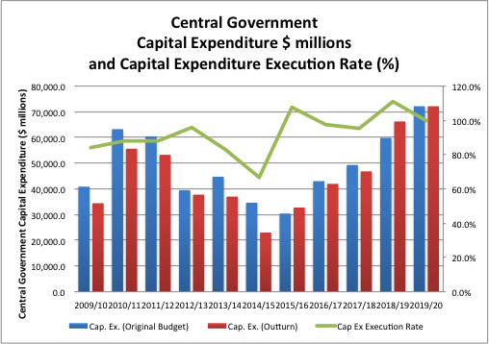

This Mr. Speaker is moving in the right direction.

For the nine months to December we were behind our budget to an appreciable degree due to significant delays in the South Coast Highway. However with focus and a determination to hit that capital expenditure budget, we elevated other projects in the public investment pipeline and made adjustments through the Supplementary process and are on track for 100% capital expenditure execution for 2019/20

2.11 Employment

Mr. Speaker, I stand before you today for yet another year and say to you that unemployment in Jamaica is at a historic, record low.

Mr. Speaker, it’s not the same record from last budget speech that I’m talking about.

That is an old record.

Unemployment in Jamaica is at a NEW historic record low of 7.2%.

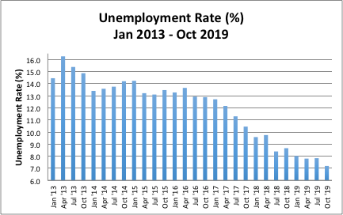

Never, in the entire history of Jamaica, have as many Jamaicans been employed as are employed today…approximately 1,250,000 employed Jamaicans.

Mr. Speaker, Jamaica is moving in the right direction.

According to data from STATIN, over the last four years, between October 2015 and October 2019, over 100,000 new jobs have been created.

Again Mr Speaker, Jamaica is moving in the right direction.

Mr. Speaker when you open the Sunday newspaper up, whereas a few years ago there was only one section of 6 or 7 pages advertising jobs. Today, Mr. Speaker, the same Sunday newspaper has three separate sections advertising jobs, with almost twenty pages of jobs advertised in the Sunday newspaper.

2.12 Employment Gender Gap

When one looks at the employment data by gender, Mr. Speaker, one observes even more positive trends.

Female unemployment was 20% in 2013 and fell to a historic low of 8.6% in October 2019.

Male unemployment in 2013 was 10.6% in October 2013, and fell to a historic low of 6.0% in October 2019.

So Mr Speaker the negative difference in female and male unemployment which used to be 9.4% has been decimated, has been demolished, has been smashed to only 2.6%.

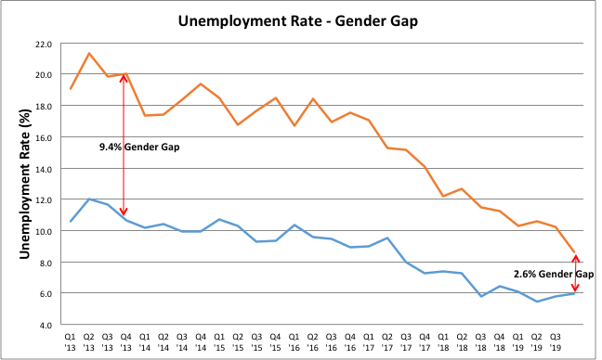

Mr. Speaker this employment in this economy has been good for everyone but it has been especially good for women.

While the rest of the world talks about increasing female labor force participation, we are ahead of the curve – our women are leading the way.

Jamaica, Mr. Speaker, is certainly moving in the right direction.

2.13 Reconciling Record Employment and Low Growth

It may pose a challenge for some to reconcile our historic employment achievements with low headline economic growth.

The explanation is relatively simple. Jamaica’s growth of 0.6% for 2019/20 is primarily due to significant negative performance in one sector in particular – the mining sector – which declined by 17.6% in the quarter ended September 2019 and is expected to decline by further 38.7% in the quarter ended December 2019.

Mr. Speaker, the mining sector is important for many reasons but mining and quarrying employs 7,425 persons out of an employed labour force of 1,245,000 or only 0.6%.

On the other hand, just by way of example, sectors like:

- Tourism (ie hotels & restaurant services), which employs 106,000 persons, has been growing for every single quarter of the last four years (and before)

- Wholesale & retail, which employs 244,375 persons, grew every quarter for the last four years except one and

- Real Estate, Renting & Business Activities, which employs 92,400 persons, and grew for all quarters of the last four years.

Many, many sectors in the economy that employ hundreds of thousands of persons are growing and expanding. And, as these sectors grow, so does employment.

Now it is true that the jobs we are creating in Jamaica are not exactly the same as the jobs being created in Singapore today.

However, Mr Speaker, remember we have to use what we have to get where we want to go.

When Singapore had their textile jobs in the 1960’s, them never cuss it, they cherished the opportunity and they used it to get to where they wanted to go

When Singapore had their manufacturing jobs in the 1970’s them never diss it, they cherished the opportunity and they used it to get to where they wanted to go.

There is a young man Donmar from Torrington Park who has a customer service job at a BPO.

2.13 Debt

Mr. Speaker, Jamaica’s Debt to GDP ratio is projected to decline to 90.2% at the end of this financial year.

Given that Jamaica’s debt was as high as 145% only seven years ago this achievement is nothing less than remarkable.

Importantly we have achieved this feat without any debt write-off or debt forgiveness.

Today, Jamaica stands as a powerful and positive example to the world.

The fiscal policy paper projects that debt will fall to 87.5% by the end of the fiscal year.

Jamaica, Mr. Speaker, is moving in the right direction

2.14 Credit Rating

Jamaica relies on the international capital markets for financing and our private sector needs access to capital inflows from overseas. A credit rating provides independent, objective, rational view of the riskiness of a particular asset. As Jamaica’s credit rating improves, access to capital by government, businesses and households improve, and the terms of that access also improve.

Mr. Speaker, in September 2019, Standard & Poors, the international credit rating agency, upgraded Jamaica’s credit rating to B+ which is the highest credit rating Standard & Poors has assigned to Jamaica’s debt in almost 20 years.

Mr Speaker, in December 2019, Moody’s, another international credit rating agency upgraded Jamaica’s credit rating to B2 which is the highest credit rating Moody’s has assigned to Jamaica’s debt in almost 10 years.

Mr Speaker, in January 2020, Fitch, another international credit rating agency, upgraded Jamaica’s outlook from stable to positive and reaffirmed Jamaica’s credit rating at B+, which is the highest credit rating Fitch has ever assigned to Jamaica’s debt.

Not one credit rating agency, Mr Speaker, not two credit rating agencies, Mr Speaker, but all three major international credit rating agencies upgraded Jamaica’s credit rating or outlook in a single financial year.

By being upgraded by international credit agencies, Mr. Speaker, Jamaica is moving in the right direction.

2.15 Monetary Policy

Mr Speaker, monetary policy has been anchored around the objective of maintaining inflation within the BOJ’s 4% - 6% target range.

The Central Bank reduced the policy interest rate four times between January and September 2019 to a historic low of 0.5%.

Since April 2016, the Central Bank reduced the policy rate 14 times bringing it from 5.25% in 2016 to the current low of 0.5% today.

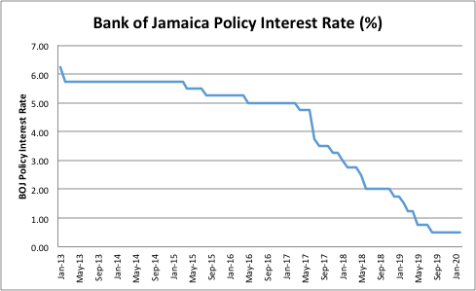

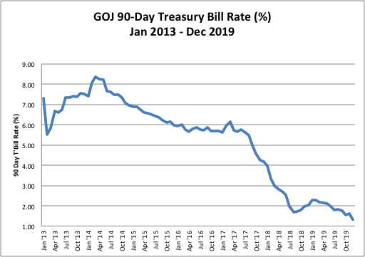

The GOJ Treasury Bill Rate has been substantially reduced as well, along with market interest rates.

In addition the BOJ reduced the cash reserve ratio (CRR) from 12% to 9% effective March 1, 2019. A further 2.0 percentage points reduction in the CRR to 7% was implemented on June 3, 2019. These actions cumulatively injected over $28 billion into the banking system.

These monetary policy actions by the BOJ have stimulated the credit market with the growth in loans to the productive sector extended by deposit-taking institutions increasing by 16.1% and loans to households growing by 14.5% over the period January 2019 to January 2020.

Mr. Speaker, Jamaica is moving in the right direction.

2.16 Inflation

Inflation has been low, stable and predictable for the past four years. Inflation for the fiscal years 2016/17, 2017/18, 2018/19 and year-to-date 2019/20 have been 4.1%, 3.9%, 3.4% and 5.2% respectively.

Since we started measuring inflation, there is no other four-year period in history where you will find four consecutive fiscal years of inflation as low as this.

Mr. Speaker, Jamaica is moving in the right direction.

Mr. Speaker, investors today are committing to 10 and 15-year instruments at low rates and are expanding and opening new factories and constructing multi-storey buildings with optimism, while households are saving at a rate higher than in the past.

Mr. Speaker, these choices and actions of investors and households arise from, and are consistent with, the current environment characterized by price stability.

Actions always speak louder than words, Mr. Speaker.

Jamaica is moving in the right direction.

2.17 The Consumer Price Index

Mr. Speaker, the inflation rate is measured by changes in the Consumer Price Index (CPI) and the CPI is composed of a weighted measure of the prices of over 500 goods consumed in our economy.

The identification of those goods and the weights applied are determined from an extensive Household Expenditure Survey (HES), conducted by STATIN, which measures the expenditure undertaken by households throughout the year. The HES is a rigourous undertaking, conducted over twelve months to capture seasonality, and ranks only second to the national census in scale, complexity and cost.

The weighting of a particular good or service in the basket is calculated by dividing the amount Jamaicans spend on that good or service, as determined by the HES, by the total consumption of all Jamaicans on all goods and services, also as determined by the HES.

STATIN endeavours to conduct a HES every ten years, consistent with international best standards for developing countries.

A HES was conducted in 2005 and another was due in 2015. STATIN reports that a budget for the HES was submitted for consideration in 2014/15 but, presumably, due to fiscal constraints, it was not approved. STATIN was therefore unable to conduct the HES in the year in which it was due.

An allocation was made in the 2016/17 budget for the HES to be conducted and it was completed over 12 months in 2017. STATIN is currently engaged in the data analysis process, with a projected release of the CPI based on the revised basket for April 2020, to be published in May 2020.

2.18 Foreign Exchange

Mr. Speaker, Jamaica operates a market-determined exchange rate. The BOJ has enacted many reforms designed to deepen the market, improve its functioning, and allow the BOJ to reduce its footprint in the market.

The Central Bank has gross reserves of US$3.6 billion and non-borrowed reserves in excess of US$2.5 billion, more than we have ever had.

In fact, Mr Speaker since October 2016, BOJ’s non-borrowed reserves increased by over US$1 billion.

Mr. Speaker, Jamaica is moving in the right direction.

The data show that, to date, annual inflows of foreign exchange to Jamaica have been more than sufficient to meet Jamaica’s needs – the proof lies in the fact that Jamaica has been able to increase its foreign exchange reserves while also rapidly increasing its non-borrowed reserves.

The challenge is that — like in every other country in the world — inflows and outflows are not balanced at every point in time. And this is where market forces are best able to resolve these short-term imbalances with price (i.e., exchange rate) movements, without the need for excessive central bank intervention.

Our market is developing, no doubt with teething pains. However, as it develops, there has been less need for use of precious reserves in the market.

The reserves in your central bank are a public resource and belong to all Jamaicans. We need our reserves to protect us against shocks in the external environment.

The BOJ has been reducing its use of reserves for intervention in the foreign exchange market and relying on demand/supply market forces to resolve those imbalances, in order to preserve our foreign exchange reserves for a genuine rainy day and so provide and maintain sustainable economic independence for Jamaica.

Between March 2013 and June 2017 when BFXITT was introduced, the BOJ intervened in the foreign exchange market to the tune of US$2.5 billion. This would not have been apparent because prior to recent reforms, the BOJ did not need to disclose its intervention. It was not a transparent and open process.

Between July 2017 and November 2019 BOJ’s interventions totaled US$740 million. Measured on a monthly basis over both periods, BOJ’s interventions have declined by 50%

This has allowed the BOJ to increase non-borrowed reserves by US$1 billion.

All of this translates into improved credit ratings, improved credit terms, and lower interest rates for businesses and households.

There is a stark choice. “Management” of the exchange rate as we use to do, with excessive intervention, compromises long term sustainability and economic independence.

Having said that there is much work to be done to improve the efficiency and depth of the foreign exchange market.

- The Bank of Jamaica will be rolling out the first phase of its foreign exchange trading platform this month (March), which should promote greater inter-bank trading and increase the depth and liquidity of the market.

- The Bank of Jamaica is also working on introducing derivative products such as forwards and swaps to assist in improving the functionality of the foreign exchange market and the experience of end-users.

- Furthermore, the Bank of Jamaica will increase the limit below which regulatory approval is not required for the issue of US$ securities.

2.19 Current Account

Mr. Speaker the latest figures from the Bank of Jamaica indicate that Jamaica’s current account deficit has been in the region of between 2% and 3% of GDP, which has been readily financed by inflows of Foreign Direct Investment and, at these levels, is sustainable.

The current account, Mr Speaker, which, in addition to incorporating the Jamaica’s trade deficit adds: net foreign exchange earned from the trade in services (in which tourism is a significant factor), foreign exchange transfers (in which remittances are dominant) and net foreign exchange used or earned in the repatriation of income to/from Jamaica.

In the past, Mr. Speaker, our fiscal deficit was only one of several unsustainable metrics. Also unsustainable was Jamaica’s current account deficit.

In FY 2011/12, Jamaica’s current account deficit was 13.6% of GDP. This fell to 10.3% of GDP in FY 2012/13, 8.7% of GDP in FY 2013/14, 6.9% of GDP in FY 2014/15 and has been between 2% and 3% of GDP over the past three years.

A high current account deficit presents significant challenges in terms of financing it. Ultimately it leads to a depletion of reserves and is therefore unsustainable. At current levels, our current account deficit is readily financed by inflows of programmed foreign direct investment.

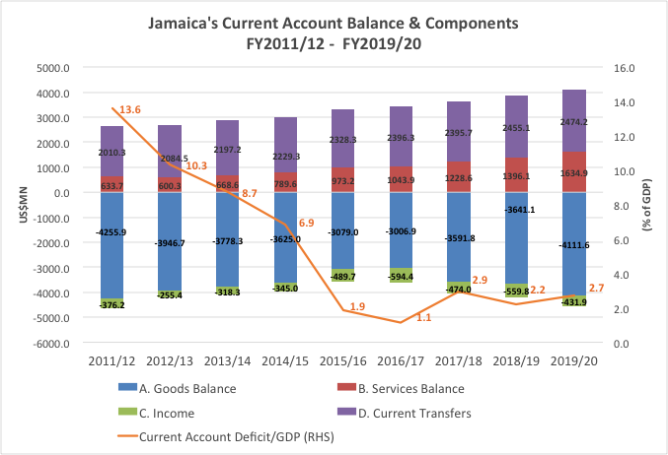

3.0 Highlights of Other Achievements

3.1 Tax Cuts Made Permanent

Mr. Speaker, during this financial year, I had the distinct pleasure of introducing, debating, and passing legislation, with the support of members of this honourable House, to make permanent the tax cuts introduced by way of Provisional Order on the announcements made in last year’s budget presentation.

Specifically Mr. Speaker we passed legislation to make permanent the

- abolishment of the minimum business tax

- abolishment of the asset tax for unregulated entities

- abolishment of ad valorem stamp duty

- reduction in the transfer tax; and

- increase in the GCT threshold from $3 million to $10 million

In the passage of the legislation we had the cooperation of the Opposition, in particular, with respect to the legislation to ensure that small businesses who wish to remain registered though their sales fall under the new GCT threshold of $10 million.

Mr. Speaker, Jamaica is moving in the right direction.

3.2 New Public Procurement Regime
Mr. Speaker, this government has taken steps to ensure that Jamaica’s public procurement system is modernised and optimised to deliver efficient and effective government contracting. This House is reminded that the new public procurement legislation entered into force on April 1, 2019, and the regulations governing the Public Procurement Commission were passed in the second quarter of the FY2019/20, paving the way for the full operations of the Public Procurement Commission. As the regime is operationalised, the Ministry of Finance and the Public Service has been receiving valuable feedback from procurement practitioners, suppliers and other interested procurement actors, and continues to make the necessary improvements.

Key amongst the reforms is the government’s continued progress towards the inclusive participation of Jamaican suppliers in the government procurement process:

Orders for Special and Differential Treatment Measures known as Set Asides and Domestic Margins of Preference were passed in November 2019, paving the way for Medium-Sized, Small and Micro Enterprises (MSME) and Jamaican suppliers to secure government contracts.

- Since the passage of these orders, pilot entities in collaboration with the Ministry of Industry, Commerce, Agriculture and Fisheries, the Ministry of Finance and the Public Service, and the Trade Board have been working to refine the policies and the operational guidelines to ensure that all procuring entities can successfully operationalise the law, and that the MSMEs and Jamaican suppliers generally can benefit. The full roll-out is expected to commence in the 3rd quarter of the upcoming fiscal year.
In addition to the specific policies that are meant to increase the participation of otherwise disadvantaged economic actors, this government has recognized that procurement is, and must be, regarded as a commercial undertaking with economic implications, rather than a set of legal rules without basis. Procurement is concerned with getting the business of government done. With this in mind, the Ministry of Finance and the Public Service continues to make efforts to simplify procurement processes and documents, aimed at increasing the ease of doing business with government, and improving the experience of the users of the procurement system:

- A new public procurement practitioner’s manual is to be issued by the 2nd quarter of the fiscal year 2020/21. This manual will assist practitioners and other involved parties to navigate the new regime- making prudent decisions in Jamaica’s interest; and

- Simplified standard documents that are used in the solicitation stage of procurement will be issued to procuring entities for use, replacing the cumbersome and difficult documents currently in play. This is expected to be completed by the 2nd quarter of the fiscal year 2020/21.
Finally Mr Speaker, this government understands the need to improve procurement performance. It is well accepted that policies that are developed based on careful collection and analysis of data are effective in increasing performance. To this end, the Ministry will be focusing its efforts on collecting and analyzing government-wide procurement data. Particularly, the Ministry will:

- Undertake more ambitious campaigns to increase the public sector adoption of the Government of Jamaica Electronic Procurement System (GOJEP), and onboarding of suppliers. The GOJEP serves as a key repository for government procurement information and must be used to its fullest extent; and

- Undertake statistical data collection and analysis to identify procurement issues, at the level of the procuring entity, as well as in the higher approving authorities with a view to implementing effective solutions.

Mr. Speaker, Jamaica is moving in the right direction.

3.3 Pension Fund Modernisation

Mr Speaker, I was pleased to table regulations – the Pensions (Superannuation Funds & Retirement Schemes) (Investment) (Amendment) Regulations of 2019 - that modernize the regulations that govern pension fund investments. These regulations were debated and passed by both Houses of Parliament and became effective this year. I recognize the input and cooperation of the Opposition.

These amendments broaden the range of permissible assets in which pension plans can invest and strengthen the legislative framework with respect to safeguarding the assets of pension plans.

The amendments will provide higher return investment opportunities for pension funds while improving access to finance, deepening capital markets, and providing options for financing for businesses outside of the traditional banking sector.

Mr. Speaker, Jamaica is moving in the right direction.

Mr. Speaker, as we move into a new regime that is underpinned and anchored by macro-economic stability, where the Government’s appetite for debt is reduced, and where pension funds have the capital they need to invest, it is necessary to broaden the range of assets that pension funds can invest in. Furthermore, in this new era of low, stable, and predictable inflation, pension plans will need to be able to invest in higher returning longer-term assets to be in a position to fund their pension liabilities. That is exactly what these amendments are intended to achieve.

3.4 Public Body Governance

The regulation to govern the nomination, selection and appointment of persons to serve on the boards of public bodies, which is the culmination of long process, was tabled in and passed by the House during the year.

These regulations prescribe the process for the nomination, selection, and appointment of persons to the Board of public bodies. The regulations will improve the transparency of the process, and will provide an opportunity for a wider pool of Jamaicans to serve on the board of public bodies. The new regulations will therefore deepen the participation in our democracy. The new regulations will also provide greater assurance that the appropriate skills, relevant expertise and necessary experience are available to boards of public bodies.

Mr. Speaker, Jamaica is moving in the right direction.

3.5 Customs Act

Mr. Speaker during the year we tabled a bill to repeal and replace the Customs Act, which will seek to modernized Jamaica’s Customs procedures.

As an open economy where trade in visible and invisible goods represents approximately 70% of GDP, it is essential and our border procedures are fast, efficient, competitive and secure.

The Bill positions the Customs Agency not solely as a collector of revenue for Government but as a facilitator of economic activity.

The Bill is now before a Joint Select Committee of both Houses of Parliament and I look forward to a robust but efficient process so that a bill, no doubt improved by the Joint Select process, can become law.

Mr. Speaker, Jamaica is moving in the right direction.

3.6 Micro-Credit Act

During the year we tabled a bill to regulate the micro-credit sector allowing for risk-based supervision of the sector and bringing Jamaica into compliance with our Anti-Money Laundering and Countering of Terrorist Financing obligations.

Over the past two decades, there has been a proliferation of entities engaged in the private money lending business.

The bill seeks to ensure that proper standards are maintained, accurate records are kept, false and misleading advertisements are prohibited, and the use of intimidation in the collection of debt is also prohibited. Very importantly, the bill seeks to prevent micro-credit institutions from being misused for money laundering purposes.

Since tabling the bill, we have had several rounds of discussions with the micro-credit sector and largely agreed on a set of amendments which we plan to bring to the House in the first half of the new financial year.

3.7 BOJ Modernisation

Mr. Speaker, the bill to modernize the Bank of Jamaica has been considered by a Joint Select Committee of both Houses of Parliament and the report of that committee has been drafted and reviewed by the Committee. The final stage of the Committee’s work will be the review of the drafted amendments that arise from the report. I expect this to be completed within the first quarter of the new financial year and thereafter the report along with the proposed amendments will be tabled in the House for debate.

3.8 Fiscal Council

Mr. Speaker, the bill for strengthening fiscal responsibility by establishing a Fiscal Council as an Independent Fiscal Institution is being drafted and will be tabled in the upcoming financial year.

3.9 Wigton IPO

Our privatization programme is designed to:

- release resources that can be employed to accelerate debt reduction

- provide assets for Jamaicans to invest in as the Government reduces its appetite for debt, and

- broaden the ownership base of the Jamaican economy and give Jamaican investors a chance to invest in sectors of the economy where local Jamaican investors have been under-represented or not represented at all.

In the last three decades, international investors have done well investing in many industries, including telecommunications, energy, and infrastructure.

Mr Speaker, the time has come for Jamaicans to also benefit from these opportunities.

In April of last year, Jamaica’s privatization programme took a momentous step forward with the privatization of Wigton Windfarm by way of a sale of 100% of the company in an initial public offering on the Jamaica Stock Exchange.

The Government sought to raise $5.5 billion. We are pleased to report, however, Mr. Speaker, that applications for the shares exceeded $14 billion.

At the time, this was a record IPO, the largest IPO in Jamaica’s history.

Over 31,000 Jamaicans are now shareholders in Wigton including an estimated 11,000 who invested in the Jamaica Stock Exchange for the very first time.

Mr. Speaker, the Government reserved shares in the Wigton offering for public sector employees, who purchased in aggregate over $1 billion of shares, whose share price has since increased by over 50%.

Mr. Speaker, Jamaica is moving in the right direction.

What is more, Mr Speaker, is that the Government introduced a bottom-up distribution strategy. When IPOs are over-subscribed, how are the shares usually rationed? Many private sector IPOs ration on a first-come, first-serve basis, which favours those connected to the broker-dealer or the company going public.

The Government instead is allocating on the basis of ensuring that all small order applications are filled first, before medium size applications, before large applications. And it does not matter when those applications are made, so as long as it is before the expiration of the offer.

So Mr Speaker, the small investor who applies last, in our system has their application filled before the large investor who applies first.

That is how you broaden ownership, Mr Speaker. That is how you give people a chance, an opportunity to climb the economic ladder.

As a result of that bottom up approach, people felt included and responded overwhelmingly with long lines at brokerage houses.

When we broaden ownership in this way, when more and more Jamaicans share in the risk and reward of economic ownership of the country’s productive assets, we create a more equitable society, and a more sustainable society.

Mr. Speaker, Jamaica is moving in the right direction.

3.10 TransJamaica IPO

Mr. Speaker, TransJamaica Highway was a private sector company owned by international investors who constructed the East-West Highway starting in 2001 and who have owned and operated it since that time up until the end of 2019.

The Government participated in TransJamaica, through NROCC, by way of participating preference shares.

In early 2019 Bouyges, Vinci, IFC and Proparco, the previous owners of the TransJamaica Highway, confirmed their willingness to sell their shareholding.

With our philosophy of economic opportunity for all, our policy to broaden the ownership base of the Jamaican economy, our thrust to release resources for the acceleration of debt repayment, and the employment of a commercial mindset, we saw in this situation an opportunity for a convergence of these policy objectives.

Mr Speaker, we set out to acquire TransJamaica with the intention of restructuring the balance sheet, refinancing the debt obligations, thereby creating additional value, and then selling the asset to the Jamaican people by way of an Initial Public Offering on the Jamaica Stock Exchange for the same price that we acquired it for.

The acquisition of TransJamaica by the Government was completed on December 19 and within approximately 45 days thereafter:

- an international credit rating was completed with TransJamaica earning a BB- rating

- the balance sheet was restructured

- the debt was refinanced with the proceeds of an international bond issue, and

- the IPO prospectus for sale by the GOJ was issued to the investing public.

The refinancing of the debt, which was mandatory on the change of control, saw the cost of TransJamaica’s debt being reduced from approximately 9% to 5.75% as well as less onerous debt terms that released more cash into the company.

While the IPO has provided a very attractive asset for the investing public, the pre-IPO balance sheet restructuring coupled with the refinancing of the debt obligations is expected to yield significant value of J$8.5 billion for the Government of Jamaica. Future value of $3.8 billion is expected to come later this year when the GOJ sells preference shares it still owns in TransJamaica.

That is, Mr. Speaker, for an asset that the Government did not own prior to December 2019, and only had preference shares which were on the books for approximately $3.6 billion, the Government of Jamaica will realise approximately J$12.7 billion in cash this year from these series of transactions which will be put towards acceleration of debt repayment and the government will still own 20% in TransJamaica.

With creativity and innovation, Mr. Speaker, Jamaica is moving in the right direction.

Mr Speaker, the records we set with the size and distribution of the Wigton IPO have within months been surpassed.

The TransJamaica IPO, which closed last week, broke, all records established by the Wigton Windfarm IPO.

Mr Speaker, we had 36,428 applications, the most applications of any IPO in Jamaica.

Mr Speaker, we went to the market with 8 billion shares on offer and had to upsize to 10 billion shares.

Mr Speaker we had applications for $25.5 billion, far exceeding the $14 billion on offer and, by far, the largest of any IPO in the history of Jamaica.

And of course, Mr. Speaker, the Government again reserved shares for public sector employees, whose applications totaled approximately $1.4 billion.

Mr. Speaker, Jamaica is moving in the right direction.

3.11 Public Sector Transformation

Mr. Speaker, achieving economic growth and development is inextricably linked to having an efficient and effective public administration.

The speed at which the public sector is able to respond to the needs of the citizenry is crucial to personal well-being and economic advancement.

Whether you are an investor, small entrepreneur, an ordinary citizen or a public servant, we all want better public services.

We are already seeing signs of the impact of public sector transformation.

We will build on these gains to achieve a public service that enables and supports our economic development.

3.11.1 Rationalisation of Public Bodies

Mr. Speaker, forty one (41) public bodies have been rationalised through, closures, mergers, and integration of functions into parent ministries to eliminate waste and duplication. The rationalization of public bodies continues in the new financial year.

3.11.2 Compensation Management
Mr Speaker, work has commenced under our compensation management project. We have procured the services of an international consulting firm who are working with the GOJ team and are now in the design phase of the project. Important components of the project are
- a review of GOJ compensation system which should also indicate the current positioning of GOJ within the Jamaican market

- the development of a proposal for a pay-for-performance and reward framework; and

- development of a compensation philosophy and policy.

For the upcoming financial year we plan to submit a proposal for a new compensation framework to Cabinet by December.

3.11.3 MyHR+ - the integrated HR and Payroll system

Mr Speaker, we have installed an integrated HR and payroll system called myHR+ across 22 ministries, departments and/or agencies. Cumulatively, 19,500 employees now have access to the system and these HR departments now have accurate and current data for decision-making. For payroll, MyHR+ facilitates more accurate and automated calculations.

In the new financial year, the HR software will be implemented in an additional 15 agencies. In addition, the design for the online work permit system will be completed.

4.0 Strategic Initiatives

4.1 Disaster Risk Financing

Mr Speaker, we know from experience of Jamaica’s susceptibility to natural disaster events. Flood rains, tropical storms, hurricanes and earthquakes have been part of the Jamaican experience.

Natural disasters events have huge fiscal impact. They have the potential of sharply reducing government revenues in the immediate aftermath of an event, and for months thereafter.

At the same time, the expenses of government increase as immediate emergency response to the disaster is required. As a result, space for priority spending on critical areas is often diverted to address emergency response to disaster.

Over time Mr Speaker, if proper fiscal plans are not made, frequent exposure to natural disaster events can lead to under-development of our country.

Mr Speaker, I crave your indulgence to share an anecdote that has informed the policy approach.

In my prior role as Ambassador of Economic Affairs and Economic Policy Advisor to the Prime Minister working out of his office, I had the responsibility of being the primary interlocutor with the IMF post-February 2016 inclusive of negotiating the follow-on Precautionary Stand By Arrangement.

The 13th review under the Extended Fund Facility was successfully completed and we were scheduled to have a press conference to announce the then-new US$1.6 billion Precautionary Stand-By Agreement.

The Head of the Western Hemisphere from the IMF was to come for that. Mr Speaker, Hurricane Matthew intervened, and for 48 hours this Category 5 Hurricane was headed directly towards Jamaica. Emergency plans were in high gear and 900 shelters were opened across the country.

Meanwhile The Fund Staff who were visiting were eventually ordered to leave Jamaica (like many others) and took the last flight out of Kingston before the airport closed awaiting the hurricane’s arrival. Of course, the Western Hemisphere Head could no longer come.

It was a surreal experience from the perspective of coming to terms with the economicl exposure over those anxious 48 hours. Jamaica was completely exposed. Mr. Speaker, the programme we had just negotiated with IMF and were set to announce (but not yet approved by the IMF Board) would have been woefully insufficient and meaningless had a direct hit of that hurricane occurred, as seemed likely in those moments. Furthermore, much of the fiscal progress under the EFF would have been completely erased.

Luckily for Jamaica, at the very last minute Hurricane Matthew veered sharply north, and tragically hit Haiti, where over 500 persons died and much of the country was destroyed, causing billions and billions of dollars in damage.

Mr. Speaker, it was at that time that I resolved to do my best to ensure that, given all the work Jamaica has done in reforming our economy and given all the hope and optimism this has engendered, Jamaica would never again remain completely exposed in the event of serious natural disaster.

Since then, Mr. Speaker, with the support of the Prime Minister and Cabinet, stakeholders have come on board with the absolute necessity of always having in place financing specifically for the risk of natural disaster.

Mr. Speaker, with the assistance of our multilateral partners including the World Bank the IDB, and the IMF, Jamaica’s Disaster Risk Financing Framework is now the most advanced in the Caribbean region.

We are implementing a multi-layer strategy with a menu of financial instruments to manage the financing of disaster risk.

Disaster risk varies in probability and severity and can be segmented into low, medium, and high-risk segments. The Government has addressed the low-risk, high-frequency segment, such as local floods, with the inclusion of an annual budgetary contingency amount. We have also capitalised our contingency fund with $2 billion representing another layer of available financing for this layer of risk.

The medium-risk segment is addressed by our entry into a $40 billion contingent credit facility with the IDB that disburses within 5 days of a major natural disaster event and provides 25 years to repay with a 5-year grace period. The Government has also addressed the high-risk segment through the Caribbean Catastrophe Risk Insurance Facility (CCRIF) that provides in aggregate over $30 billion of coverage across a variety of risks including hurricanes, earthquakes, and excess rainfall.

Mr Speaker we are also addressing the high-risk segment further by entry into a catastrophe insurance bond through the World Bank.

These latter two financial instruments represent a transfer of risk to third parties, which is essential. The other layers represent a retention of risk by us in one way or another

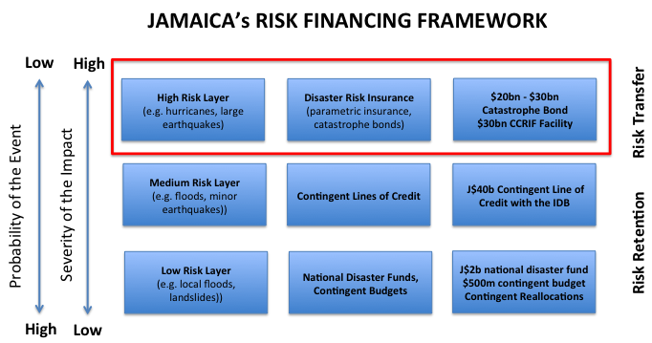

4.1.2 Catastrophe Bond

Permit me, Mr. Speaker, to say a few words about the historic Catastrophe Bond.

This kind of risk transfer has been used by other countries such as Mexico, Chile, Colombia, and Peru to manage their national exposure to disaster events.

Under this risk transfer product Jamaica will pay an annual premium and, if there is a natural disaster event that breaches certain pre-determined criteria, there would be a financial payout to Jamaica.

The Triple-A rated World Bank will stand between ourselves and the international capital market investors and will be our counterpart to whom we pay the annual premium, and from whom we would receive payout.

Mr Speaker, you can’t have a better counterparty for a transaction like this than the World Bank.

The further good news, Mr Speaker, is that the international community has responded favorably in support of Jamaica’s effort to proactively take accountability for our vulnerabilities.

The Governments of the United Kingdom and Germany, through a World Bank managed fund to which they are the main contributors, are supporting Jamaica with a grant of US$14.85 million or approximately J$2 billion.

In addition, Mr. Speaker, the Government of the United States, through USAID, is supporting Jamaica with a grant of US$5 million or nearly J$700 million.

With the assistance of the UK, Germany, and the US we are moving in the right direction to protect Jamaica from the financial impact of natural disaster.

This is great assistance, Mr Speaker, for a very serious risk that we will always face. Our commitment to our partners is that we will continue with the risk transfer coverage on renewal of the instrument in three years, from our own resources, at which time we expect to be an improved fiscal position with even lower debt.

It is the hope and vision, Mr Speaker that on the renewal in three years we will be able to enter into a Caribbean-wide catastrophe coverage that will provide even larger coverage at better pricing.

We expect to place this bond in time for the upcoming hurricane season and more details will be provided.

Jamaica will be the first country in the Caribbean to protect itself from natural disaster by entry into a catastrophe bond.

Mr. Speaker, we have been working on this for two years. Others in the region have heard and will follow. Mr Speaker, we are leading the region in moving the right direction.

4.2 AML/CFT Framework

Mr. Speaker, a unified national effort is required to improve Jamaica’s Anti-Money Laundering and Counter-Terrorist Financing (“AML/CFT”) regime.

Mr Speaker, a robust AML/CFT framework is increasingly becoming a requirement for participation in the global financial system and Jamaica cannot function without access to, and participation in, the global financial system. That access, Mr. Speaker, is threatened by the deficiencies in our AML/CFT regime.

Jamaica will be working with the world governing body the Financial Action Task Force (FATF) to strengthen our AML/CFT regime. This will include:

- bringing all designated non-financial institutions and designated non-financial businesses and professions in the AML/CFT regime, including the legal profession (subject to the court’s decision), and ensuring these professions are subject to effective risk-based AML/CFT supervision

- Completing the necessary legislative amendments to bring the microfinance sector under AML/CFT requirements, and start implementation to ensure that adequate risk-based supervision of the sector is in place

- Amending the Companies Act to ensure, among other things updating beneficial ownership disclosure standards to be consistent with the FATF standards with effective, proportionate and dissuasive sanctions for legal entities in breach of their beneficial owner disclosure, and

- Strengthening the laws and risk-based supervision of the non-profit sector to improve AML/CFT compliance.

With our efforts to integrate Jamaica more effectively and transparently into the international financial system, Jamaica is moving in the right direction.

4.3 Open Government Partnership

Mr. Speaker, in December 2016, this administration communicated its interest in joining the Open Government Partnership (OGP), a multilateral initiative in which participating governments implement commitments to promote greater transparency, engage citizens in the policy-making process, and use innovation to improve public service delivery.

Since its launch in 2011, the OGP’s membership has grown to include 78 countries and 20 local governments. As members of the OGP, each country outlines a series of open government commitments that they commit to executing within a two-year implementation cycle. This collection of commitments is known as an OGP National Action Plan.

For Jamaica, participation in the OGP represents a natural progression of the ongoing reform agenda that this administration is pursuing across the public service.

Initiatives such as the Citizens Guide to the Budget, which increase understanding and transparency of how the government’s budget affects the lives of everyday Jamaicans, and Jamaica’s recent signature of the Escazu agreement, which seeks to promote greater public participation in environmental decision-making, are examples of the types of commitments that the OGP community seeks to encourage.

We intend to publish Jamaica’s first OGP National Action Plan by December of this year. The commitments that make up a National Action Plan are developed in collaboration with civil society and the public through a series of online and in-person consultations. We have already begun discussions with a civil society working group to develop our plan for these consultations.

The plan will be published on the Ministry of Finance’s website by the end of this month (March), with consultations beginning thereafter in April. The consultation process will be overseen by a Multi-Stakeholder Forum (MSF), an oversight body comprising equal representation of government and civil society representatives. The MSF will manage the co-creation and preparation of the National Action Plan and monitor its implementation.

We see the OGP as a platform for Jamaica to highlight our commitment to good governance. The OGP process provides a pathway for coordinating and prioritising government initiatives aimed at improving transparency and accountability. OGP membership lends local and international visibility to Jamaica’s region-leading progress in these initiatives, and by extension its commitment to fighting corruption.

With our commitment to improved governance and transparency, Jamaica is moving in the right direction.

4.4 Jamaica Public Investment Map

We are working with the IDB to increase citizen participation in the budgetary process through the Jamaica Public Investment Map.

The InvestmentMap is a publicly-accessible information management platform that visualizes and maps public investment projects with a view to improving transparency and efficiency of public investments.

The technology will be used to facilitate the government’s reform objective of increased citizens’ engagement specifically strengthening the monitoring of public investments through citizen participation, which is being pursued through the Strategic Public Sector Transformation Project.

The InvestmentMap will bolster the Citizen’s Guide to the budget, another major initiative to increase public engagement.

The Citizen’s Guide informs the public about the budget as cast and the InvestmentMap will provide current budget execution information in relation to projects

Objectives of the Public Investment Map include (a) achieving greater transparency in public investment for government officials, policymakers, businesses, media and citizens, (b) increase citizen participation, (c) reduce corruption, (d) increase government efficiency, and (d) contribute to better data governance through increased accuracy and timeliness of availability.

4.4.1 How does the Platform Work?

The platform will be accessible through a publicly available URL to be shared with the general citizenry at a public launch of the Platform at the end of April 2020.

The pilot version of the platform is ready and the project manager for the Public Investment Map and his team are working with central government in the first instance to ensure that all central government projects are included in the platform.

Later this year (post-launch), the team will ensure that other projects being implemented by the public bodies such the National Housing Trust, the National Water Commission, the Port Authority of Jamaica, and the Urban Development Cooperation are included on the platform, reflecting the current status of these projects.

The platform is intuitive and can be easily navigated by persons at all levels. Citizens will be able to see the annual budget allocated to a specific project as well as the execution of that budget as the year progresses. The platform will also allow for citizens to provide feedback on the project through a citizen participation portal.

It is important to recognize the IDB as well as the governments’ of Canada and Norway who are providing the funding for this initiative.

By increasing transparency in public investment projects, Mr. Speaker, Jamaica Mr. Speaker is moving in the right direction.

4.5 Financial Literacy

Mr. Speaker, this period of economic stability and unprecedented five-year continuous stretch of economic growth has ushered in growth of our capital markets and particularly the Jamaica Stock Exchange.

More and more companies have been able to access equity financing via the Jamaica Stock Exchange to finance expansion and development.

Jamaica is moving in the right direction with our capital market development Mr Speaker.

We are working to broaden participation through our divestment process and bottom up distribution.

To further expand opportunity Mr Speaker the Government is going to invest in financial literacy, preparing the Jamaican citizen to understand cash-flows, balance sheets, and valuations.

We believe in empowerment of the individual as the most secure way of expanding his or her economic opportunity.

Early in the new financial year, we will set aside $25 million in grants and issue a public call for proposals for individuals or organisations involved in promoting financial literacy.

Mr. Speaker, this will help move Jamaica forward with respect to financial literacy and promote what we believe which is economic opportunity for all.

We will seek to maximize coverage – that is we want financial literacy classes and material available across Jamaica and we will seek to maximize quality.

Members of the #FinanceTwitter community are here Mr. Speaker who are doing their own thing in different ways to promote understanding and literacy of economic and financial data and events.

4.6 Student Loan Policies

During the year, we implemented new student loan policies that reduced rates on student loans while also providing for the forgiveness of student loans for those who work in the non-profit sector.

Traditionally when a borrower of the Students’ Loan Bureau graduated, they were given a 6-month grace period. That is, if a borrower graduated in June of a given year their loan went into repayment on January 1 of the following year.

Mr. Speaker, we are changing that. The previous policy made delinquents out of well-intentioned students who were finding themselves in the working world, making adjustments from student life. It was also problematic for those, who despite their best efforts took longer to find jobs.

So Mr Speaker, all students who graduated in June last year, who would have ordinarily been required to begin repayment in January will now have until September 2020 to do so.

This change will be applicable to all future borrowers. That is, Mr Speaker, students will now have 14 months from graduation to begin repaying their student loan at the low rates that exist of 4% and 5%.

We expect that this change will allow the Students’ Loan Bureau to continue to fulfill its mandate of sustainably increasing access to tertiary education in Jamaica.

Mr. Speaker, Jamaica is moving in the right direction.

Configuration of the Loans Management System is being done by the developers (eGov Ja Ltd) to facilitate modernization of policy.

Good Standing Benefit
The Good Standing benefit is applicable to accounts that are in the repayment phase and are maintained on a current basis or up to 30 days past due. The benefit is also applicable to beneficiaries who are still in school (moratorium loans) and maintain a GPA of at least 2.5 for the prior academic year.
Mr Speaker, so far the benefit has been applied to approximately 75% of the eligible loans and the developers have since fixed the variances observed with the remaining 25% of the portfolio. The User test has been satisfactorily completed and will be deployed to production by March 14, 2020.
By improving access to tertiary education, Jamaica is moving in the right direction.

Employees of Registered Charities

As announced last year, Beneficiaries employed full time to a registered charitable organization for at least one year whilst his/her loan is in repayment, and are in good standing, will benefit from a 10% reduction in the principal balance.
Assessment is scheduled for the end of each fiscal year and the benefit will be applied to the first batch of eligible accounts commencing March 31, 2020.

5.0 OVERVIEW OF THE GOVERNMENT’s 2020/21 EXPENDITURE BUDGET

The FY 2020/21 Budget proposes total net expenditure of $853.5 billion, a decrease of $5.6 billion or 0.7% on the programmed expenditure for FY 2019/20. The decreased expenditure is due to lower debt service for FY 2020/21, as the non-debt expenditure is programmed to increase by 4.4%.

The total net expenditure of $853.5 billion is comprised of:
Non-Debt Recurrent Expenditure $454.2 billion
Capital Expenditure $ 74.2 billion
Non-Debt Below-the-line expenditure $ 37.3 billion

Debt Service expenditure $287.8 billion

5.1 Non-Debt Recurrent Expenditure

The non-debt recurrent expenditure of $454.2 billion represents a 4.7% increase over the programmed spend for FY 2019/20 and consists of:
Recurrent Programmes $232.9 billion; and
Compensation of Employees $221.3 billion.

The Recurrent Programmes allocation which is 5.8% greater than the programmed amount for FY 2019/20 will facilitate the operational activities of Ministries, Departments and Agencies (MDAs) which include the purchase of goods and services, subventions to supported agencies and tertiary institutions, travelling allowances, and pension payments.

This year recurrent programmes also include:

- $2.4 billion to cover the cost of both local and general Government elections;
- $0.9 billion to conduct preparatory activities for the national census;
- $2.9 billion in subvention to the University of Technology; and
- $0.8 billion towards premium payments for the catastrophe bond, as the country continues to enhance its preparedness to address natural disasters.
Employee Compensation of $221.3 billion includes application of the 5% salary increase for the fiscal year, as agreed with public sector unions. However, due to the fact that: (a) we prepaid the annual NHT arrears payment due in FY 2020/21 in advance in FY 2019/20; and (b) there were non-repeatable compensation expenses in FY 2019/20, primarily related to the Jamaica Defense Force, the budgeted overall increase in compensation in FY 2020/21 over FY 2019/20 is only 3.6%.

5.2 Capital Expenditure – Investing in Public Services

The FY 2020/21 Capital Budget of the Central Government is $74.2 billion, which is 3.3% of GDP.

Mr. Speaker, the increases in the capital budget over the past four years and our focus on achievement of 100% execution is born of our conviction that for Jamaica to continue to move forward we have to invest in our physical infrastructure, our social infrastructure, our security infrastructure and our economic infrastructure.

We are doing that Mr Speaker and we are moving Jamaica forward.

Mr. Speaker, I will now provide some details on how the Capital Expenditure budget
has been allocated.

5.2.1 Investing in Physical Infrastructure

Mr Speaker, investing in physical and social infrastructure improves labour and capital productivity and also improves quality of life.

Infrastructure

Mr Speaker, allocation to major infrastructural projects are:

- $12.917 billion for the Southern Coastal Highway Improvement Project (SCHIP) - The SCHIP aims to improve the main 110km south eastern road corridor from Harbour View, St Andrew to Port Antonio, Portland and 26km from Morant Bay to Cedar Valley, with a view to increasing commerce and stimulating economic activity and development in the eastern section Jamaica.

Also included in this project is construction of the third phase of the East–West Highway (Highway 2000) from May Pen, Clarendon to Williamsfield in Manchester (27km).

- $3.766 billion for the Montego Bay Perimeter Road - The objective of this project is to create an alternate route for motorists travelling across and within Montego Bay thereby reducing congestion within the city and opening up opportunities for structured development. The project entails construction of a 15km 4-lane carriageway from Ironshore to Bogue in Montego Bay and the rehabilitation/improvement of intersections within the city.

- $350 million for completion of the Major Infrastructure Development Programme (MIDP).

- $534 million for the Road Rehabilitation Project – which will upgrade road networks in Trelawny, Manchester, and Clarendon (Soursop Turn to Danks and Danks to Mears Bridges) totalling 47km.

- $538 million for the Montego Bay Waterfront Protection Project – This project involves the rehabilitation of the Montego Bay Groynes to reduce the loss of beachfront acreage to coastal erosion.

- $881 million for the Montego Bay Closed Harbour Beach Park – provision of a 6.5 hectare public park for the people of the parish of St James by the beach with pavilion, jogging trail, boardwalk, recreational facilities, public restrooms and life guard stations.
- $528 million for Rural Water Supply – upgrading rural water supplies in sections of St Mary, St Catherine, Portland, St Thomas and St James through rehabilitation of catchment tanks and installation of rainwater harvesting systems.

5.2.2 Investing in Social Infrastructure

Mr Speaker we are not only investing in improving physical infrastructure, we are investing to improve our social infrastructure to improve quality of life, improve life outcomes, and to improve the delivery of public services.

Capital expenditure projects include:

$1.0 billion for acquisition of a total of 50 Garbage Compactor and Tipper Trucks as phase 1 of the NSWMA Fleet Expansion Project, with delivery of an additional 50 trucks early in 2021/22 which will see a total of 100 new garbage compactor and tipper trucks over two financial years.

Mr Speaker, when Minister McKenzie get these new trucks, he will be able to give you a schedule and tell you that for sure the truck coming to pick your garbage on Thursday morning, and you go to your bed Wednesday night certain the truck will be there in the morning.

$1.1 billion towards the acquisition of 45 Diesel Buses and 5 electric buses for the JUTC - in order to increase the availability of buses in the Kingston Metropolitan Transport Region; Phase 2 of the project will see the acquisition of a further 20 diesel buses.

$1.9 billion for the balance on 30 Fire Trucks to be delivered this year and allocated to the Jamaica Fire Brigade to improve responsiveness to emergencies including fires

100 new garbage trucks over two years, 50 new JUTC buses, and 30 new fire trucks.

Let me ask when was the last time you hear a government do something like that at one time?

Mr Speaker, Jamaica is moving in the right direction.

5.2.2.1 Investing in the Development and Expansion of Hospitals

Mr. Speaker, we are also improving the social infrastructure of Jamaica by our investments in health and wellness where we continue to implement public investment projects aimed at strengthening the quality and level of public health services.

Mr Speaker, $3.9 billion is being allocated to improve several health facilities and continue efforts to curtail the proliferation of communicable and non-communicable diseases. Some of the major uses of these proceeds include:

$1.785 billion for the Redevelopment of the Cornwall Regional Hospital – This is being programmed to finance Phase 2B of the Cornwall Regional Hospital development project which will cover demolition and structural works to the entire facility.

$900 million for Phase 1 of the Redevelopment and Modernisation of the University Hospital or the West Indies – involves the construction of a six storey tower and investment in medical equipment at a total cost of US$33.6 million. The project is programmed for completion within two years with the following deliverables:

- Fifty-eight additional beds (12 emergency beds, 16 psychiatry beds and 30 surgical beds).
- Seven major operating theatres designed and equipped to provide joint surgery, a urology suite with robot, a brain suite, and a minimal invasive suite for general surgery and gynaecology; together with pre-op and recovery space.
- New medical equipment including ultrasounds, digital x-ray, CT scanners, a mammogram suite, a fluoroscopic suite, an MRI;

$250.8mn for the Western Children and Adolescents Hospital - This 220-bed hospital is being financed by a grant of US$43 million from the Chinese Government. We express our gratitude for that grant, Mr. Speaker. A sum of $250.8 million has been allocated in the 2020/21 budget to conclude site preparatory activities and implement other GOJ obligatory activities as well as to provide support to the execution of the project.

5.2.2.2 Investing in Education

The Ministry of Education, Youth and Information receives the largest allocation in our budget outside of amounts allocated for debt interest payments

The Ministry of Education will be allocated a total of $117 billion, which represents 22% of non-debt expenditure.

Mr Speaker the day is fast approaching where we will spend more on education than on debt interest expenditure.

We are moving in the right direction, Mr Speaker

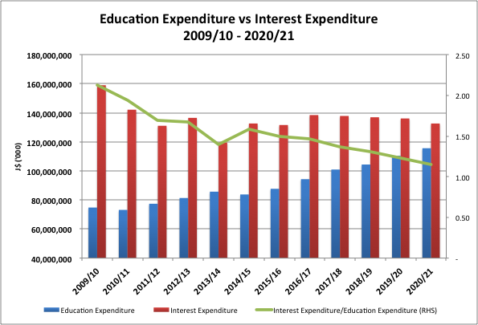

The Ministry of Education will received the largest increase in budget year over year of $5 billion. The Minister of Education will, I am sure, delight in sharing with you how this will be spent.

Mr. Speaker, I would like to highlight that, of this amount, the government will be allocating $1.1 billion to the Primary and Secondary School Infrastructure Project – to enable the removal of more schools from the shift system, undertake construction of additional classrooms, and upgrading of other school facilities. In total, Minister Samuda has announced that this project will cost $14 billion and will be implemented over three years, targeting 54 schools.

5.2.2.3 Investing in Social Services

Mr Speaker the government continues to invest in our flagship social assistance programmes. Major allocations are:

$8.287 billion for The Programme of Advancement through Health and Education (PATH Programme) - This is a targeted social assistance programme of the GOJ. Benefits are accessible in the form of cash grants for children/students ages 0 – 19 years, the adult poor, the disabled, elderly, pregnant and lactating mothers and the destitute. PATH benefits were increased by an average of 17.2% in June 2019 and will be increased further in 2020.

$4.015 billion for Jamaica Social Investment Fund (JSIF) - The JSIF has been mandated to implement several intervention programmes in the areas of education, human resource and community development, water, sanitation and drainage infrastructure, agriculture and community access.

5.2.3 Investing in National Security Infrastructure

Mr Speaker our national security infrastructure suffered from many, many years of underinvestment while we were busy with unsustainable debt and organized and street crime grew in strength, numbers and capacity.

This government is responding by equipping our security forces with what they need to address organized and street crime.

Mr Speaker the Capital Budget for the Ministry of National Security is $15.9 billion for 2020/21. Over the last four years including the current financial year, the Government has spent $44 billion in capital expenditure to upgrade the capacity of the security forces compared with approximately $10 billion in the immediately preceding four years.

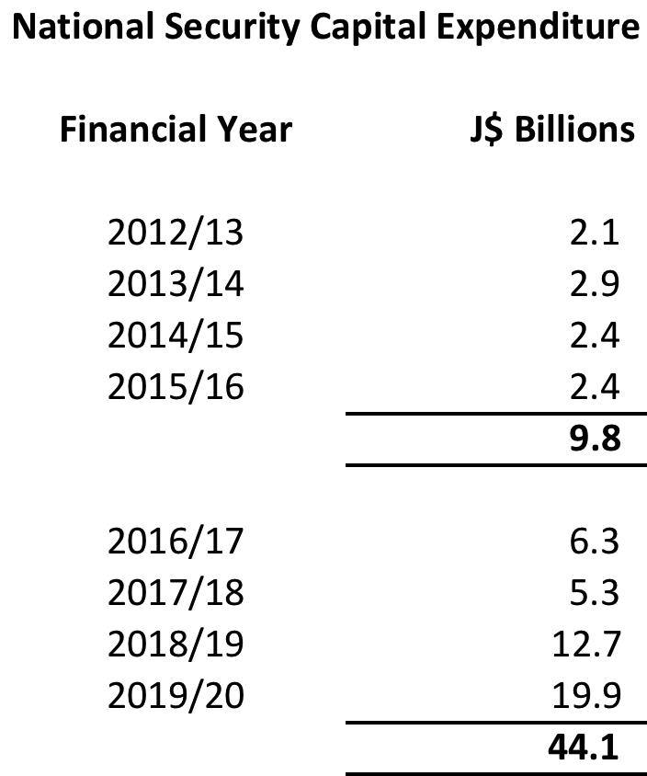

Major allocations to national security for FY 2020/21 include:

$2.3 billion for the Construction & Improvement of Police Stations & Other Buildings – which will facilitate:
a) the construction of a government-owned Forensic Pathology Autops Suite;
b) completion of the renovation of 40 police stations islandwide; and
c) production of designs and pre-investment activities of two new Police
Divsional Headquarters in St Catherine and Westmoreland and a new
national police headquarters.

$1.529 billion for the Construction of New JDF Facilities which will facilitate completion of (i) Phase 2 of the Burke Barracks; and (ii) expansion works at the Moneague Training Camp including the Military Canine Facility.

$11.1 billion for the Procurement of Equipment, including vehicles, vessels and aircraft to enhance the mobility and effectiveness of the security forces in responding to physical threats and cyber-attacks. This amount includes:

- $1.2 billion for police cars for the JCF;
- $3.0 billion installment for helicopters and fixed wing aircraft for the JDF;
- $2.8 billion for maritime patrol vessels to improve Jamaica’s border security and stem the flow of illegal weapons into Jamaica and the use of the country as a transhipment point;
- $1.2 billion for supply and installation of camera, servers and software to upgrade Jamaica’s CCTV network, “Jamaica Eye”, as well as radio communication and dispatch equipment;
- $600 million for vehicles for the JDF including armoured patrol carriers; and
- $1.8 billion for cyber security for JCF and the JDF.
Citizens Security and Justice Programme (CSJP) – this decade-old programme will continue to provide support to the current cohort of beneficiaries while preparations are undertaken to transition the activities into the respective line Ministries by January 2021.

5.2.4 Investing in Economic Infrastructure

The government is also spending to improve our economic infrastructure which will help to broaden economic opportunity, deepen our participation in higher value activities and improve our prospects for growth.

$308 million for the Global Skills Services Project - to improve the institutional and regulatory framework to promote the growth of the higher value-added segments of the Global Services Sector in Jamaica.

$612 million for the Essex Valley Irrigation Infrastructure Development Programme - which aims to enhance the production and productivity of farmers in the Essex Valley. The allocation will be used to (i) continue well drilling at alternate sites; (ii) complete the irrigation network system and global gap building designs; and (iii) commence construction of the renewable energy infrastructure and agro-processing buildings.

$1.25 billion for the Farm Roads Project – to provide improved direct access for up to 20,000 farmers for the “farms to market” transportation of farm produce, the Government will rehabilitate 80km of farm roads islandwide, which should help to improve agriculture output and increase employment in rural communities.

$830 million to the Credit Enhancement Programme for MSMEs – The objective of this project is to provide loan guarantees to Micro, Small & Medium-size Enterprises (MSMEs) which lack the collateral needed to access loans. The loan guarantees are available to MSMEs and are funded from a Credit Enhancement Fund (CEF) which was created 10 years ago.

The allocation will be used to further capitalise the fund. The re-designed CEF will be able to
- support MSMEs with over $25.0 billion in additional guarantees in four years!
- increases guarantee coverage from $15 million to $30 million per company, and
- increase guarantee coverage from 50% to 80% of the loan amount.
Moreover, the applications are now being administered through an electronic platform that facilitates immediate approval once the MSME client meets the eligibility criteria.

Mr. Speaker, over the 10 years between 2009 and 2019 the CEF provided 680 guarantees valued at $3.5 billion between 2009 and 2019.

Mr. Speaker, when we came in in 2016, we looked at something that was good and figured out how to make it much better.

Instead of providing individual guarantees on a loan-by-loan basis, we have moved to an indemnity first loss portfolio insurance model that has allowed a dramatic expansion in capacity.

Mr. Speaker, in the last 12 months alone, financial institutions have applied for $10 billion in loan guarantees on behalf of their MSME customers.

And Mr. Speaker the DBJ has the capacity to do a further $15 billion in loan guarantees for MSME’s.

Mr. Speaker, with the application of creativity, innovation and passion for what we do, Jamaica is moving in the right direction.

If that is not enough, Mr. Speaker, we will shortly sign the Boosting Innovation, Growth and Entrepreneurship Ecosystems (BIGEE) Project with the IDB and this year we are allocating $485 million to support the establishment of a Venture Capital Fund to focus on providing financing during the early stages of businesses, as well as create other financing mechanisms to support the development of MSMEs.

6.0 SOCIAL PROTECTION

I want to speak on a topic that as Minister of Finance and the Public Service and as a Member of Parliament is very dear to me, and that is social protection.

Mr. Speaker, when I was appointed Minister of Finance and the Public Service I declared that the economic policy would target three primary objectives: (i) the pursuit of economic independence, (ii) economic opportunity for all, and (iii) the protection of the vulnerable.

As such Mr Speaker, in September of 2018 and even after I reported (in 2018) on the large drop in poverty for 2016, with the consent and cooperation of Minister Robinson and her team, I requested, back in 2018, that the World Bank conduct a public expenditure review of social protection in Jamaica.

This review looked at social protection not only in the ministry of Labour and Social Security, but across all of government.

The objective of the Public Expenditure Review was to examine the efficiency, effectiveness, and equity of social protection spending in Jamaica and to identify options for improving social protection to ensure that the Government’s objective of protection of the vulnerable is met.

So Mr. Speaker, we engaged in action, and not mere words nor knee jerk response. We first set out to take stock of where we are.

The findings of the World Bank’s public expenditure review include the following:

First, Jamaica has a large portfolio of Social Protection programmes, across ministries, which seek to address risks and vulnerabilities. The challenge is to increase the efficiency, effectiveness and equity of these programmes.

Second, Jamaica’s social protection system consists of four components: (i) several social assistance programmes, (ii) social insurance, (iii) active labour market programmes and (iv) social care services.

- The flagship social assistance programme is the conditional cash transfer programme PATH. The social assistance component also includes the
  - School Feeding Programme which facilitates the regular provision of meals to school-aged children, targeted primarily to children of PATH beneficiaries
  - the National Health Fund
  - the Jamaica Drug for the Elderly Programme
  - the Poverty Reduction Programme managed by JSIF,
  - the Tuition Assistance and Examination subsidies
  - the National textbook loan scheme of the MOE, and
  - the Rural Transport Service of MTM
These complete Jamaica’s social assistance architecture.

- Social insurance includes National Insurance Scheme and the Public Pension System

- Active Labour market programmes include the HEART Trust (new name) and the HOPE Programme

- Social Care Services include the Child Protection and Family Services in charge of protecting children, the Jamaica Council of Persons with Disability, and the National Council for Senior Citizens

Third, the GOJ’s overall spending on Social Protection was estimated at 5.04% of GDP in 2019/20 and accounted for 20.55% of central government non-debt expenditure.

The World Bank’s review found that Jamaica’s social protection system has exhibited counter-cyclicality, which is a good thing, whereby social spending as a percentage of GDP increased in 2008/09 during the global financial crisis and has steadily increased over this seven year fiscal consolidation period.

Fourth, notwithstanding this, although Jamaica spends more than the average spent in Latin America on our cash transfer program (0.36% of GDP vs. the Latin American and Caribbean average of 0.27%), we spend less on social assistance overall, 1.28% of GDP vs. 1.5% of GDP for the Latin America and Caribbean average.

Fifth, coverage of Jamaica’s population and poorest quintile that are either indirect or direct beneficiaries of social protection programmes is higher than most benchmark countries.

- Based on JSLC data, 82.9% of Jamaican households report at least one person in receipt of any social assistance, social insurance, or labour market program benefit. This is above Uruguay (80% in 2012), Ecuador (73% in 2016), Montenegro (56% in 2014), and the Dominican Republic (35% in 2014).

- The coverage in the poorest quintile of our PATH Conditional Cash Transfer and School Feeding is higher at 70% than the averages for Latin American and Caribbean countries (41%).

Sixth, the NIS covers around 28% of the elderly population through Old Age Pensions, representing approximately 81,000 elderly people. In addition there are around 23,000 beneficiaries of other NIS pensions, making a total of approximately 104,00 people covered by the NIS. However, as we know from anecdotal evidence NIS coverage is unequally distributed based on income level. The lower your income the less likely you are to be included in NIS. While the higher deciles of income have 56% coverage, the poorest quintile have an average of 27% coverage. This is a decades old problem.

Seventh, a large section of the poor of working and elderly age do not qualify for PATH conditional cash transfer.

So while we are doing well on (a) total amounts allocated to social protection as a percentage of the size of our economy, (b) the existence of a wide menu of social protection programmes, (c) social protection coverage that exceeds the coverage in Latin America and the Caribbean, there still remains a significant number of vulnerable persons who are without any social protection in Jamaica.

This is a challenge that this Government has been giving active thought to and that this government is prepared to address.

Mr. Speaker, to improve coverage of our social protection among working age adults and among the elderly, the Government of Jamaica will introduce two new social assistance programmes to strengthen our social protection fabric: a public works programme targeted at the poor of working age in two parts, one of which I will address, and the other which will be addressed by the Prime Minister, and a social pension for the elderly which I will now speak to

6.1 Social Pension for the Elderly

Mr. Speaker, the National Insurance Fund was set up in in 1966 and is a compulsory, contributory, funded social security scheme.

Jamaica is among a minority of countries that have a funded social security system and to have had that from 1966 speaks to the vision of the architects of independent Jamaica. Spain does not have funded social security, France does not either. Mr Speaker, the United States of America does not have a funded social security system. But ambitious Jamaica does, Mr. Speaker.

Today the NIS is capitalized at over $120 billion. We are reforming the NIS, with phased-in increased contribution rates and thresholds, announced during the 2019/20 fiscal year and these reforms will ensure that the NIS has positive cashflows until 2048 and the Fund will last until 2057. To extend the life of the Fund beyond this will require further reform, which will be addressed by the Minister at a later date.

In the meantime, Mr. Speaker, we have the challenge of low coverage of the NIS. Out of an elderly (over 65) population of 291,373 persons only 82,063 – less than 30% – are in receipt of an NIS pension.

The elderly population not covered by the NIS reflects the historic and current high levels of informal workers present in Jamaica’s labour market. It is estimated by the World Bank, based on JSLC data, that 77% of the poorest quintile have never contributed to the NIS.

So Mr. Speaker, Miss Davis, has worked all her life. Get up 5am in the morning to take the bus to get to work, do a full eight (8) hours work sometimes more for 40 years. Church on Sunday. Children to school. She has abided by the law and played by the rules but my God, by the nature of her employment, it meant that her employer never contributed to the NIS on her behalf.

Now she is elderly and has absolutely no source of income. A proud yet struggling woman during her working years, she is now absolutely dependent and the pride of her youth has been replaced by anxiety and shame.

Mr. Speaker, Miss Davis is in this chamber. She is retired. Worked faithfully all her life. Not one penny of income in retirement and no savings.

To consistently move forward, our political freedoms must translate into sustainable material benefit and improved conditions for the Jamaican people.

This is a structural inequity in our society that should no longer go unaddressed and this Government, led by Prime Minister Andrew Holness, intends to do just that.

Miss Davis, I have good news for you. In this financial year, the Government will spend $1 billion to introduce a modest social pension targeted to cover the poor and vulnerable segment of the elderly population who are not in receipt of PATH, NIS or a private pension. It is estimated that there are 30,000 elderly persons who are poor and vulnerable and not in receipt of NIS, pension or poor relief.

We recognize that this amount is not nearly sufficient to address the needs of the elderly. But this is a start, and we must start somewhere.

In the design, Mr Speaker, we will be careful to ensure that there isn’t a disincentive to enroll in the NIS that introduces new inequities. As such the benefit level and the age at which one can qualify for this pension will differ from the NIS.

In addition, the design will ensure that the social pension is fiscally sustainable. The social pension is intended to correct historical structural inequity which make it difficult for informally employed persons to contribute to the NIS. We do not want to introduce new inequities through a fiscally unsustainable design. Therefore, the Government, through the Ministry of Labour and Social Services will innovate to increase the NIS coverage ratio so that, over the course of the next decade, the population of persons that can qualify for the new social pension, by virtue of not being in receipt of NIS AND being poor and vulnerable, decreases over time. By definition, that population will increase at first but ultimately it will hit a maximum, and then start to fall as we dramatically increase NIS coverage.

Minister Robinson will speak to further details of the design at a later date.

Mr. Speaker, I want to make it clear to the Jamaican people that, under the visionary leadership of Prime Minister Andrew Holness, and with the support of Minister Shahine Robinson, this Government intends to launch the most comprehensive reform to social security in Jamaica since the National Insurance Scheme was launched over fifty years ago in 1966.

I say to the elderly in the Jamaican society who have been deprived to the opportunity to contribute and receive a pension, like Miss Davis, Jamaica is moving in the right direction.

6.2 Social Intervention Public Work Programmes

In our public expenditure review exercise with the World Bank, the Bank pointed out that many countries have public works programme as part of their social assistance to address gaps in social assistance coverage. For example, poor and vulnerable adults who are of working age and have no school-age children are not eligible for inclusion in PATH.

I would like to share with you a programme with three components to be implemented by the NSWMA that will clean up Jamaica.

Mr Speaker, I was motivated by the experience of working with the NSWMA and the NWA to clean the section of the Sandy Gully that runs through my Constituency, St. Andrew North West.

The gully was overgrown with large trees, forty feet high and dense bush stretching for ¾ mile in the gully forming a huge impenetrable island that obstructed the natural flow in the gully and harboured criminals and rodents.

In a major exercise, the gully was thoroughly cleaned and hundreds of truckloads of trees and debris were removed.

However Mr Speaker, rain fall two time and all the rubbish in Minister Samuda’s section of the gully just wash down on my clean, pretty, pretty section.

So, that means, we have to clean Minister Samuda’s gully as well! And that is exactly what we intend to do.

Mr. Speaker, the overwhelmingly positive public reaction to the clean-up of the Sandy gully has motivated us and strengthened our resolve to broaden this initiative and do the same for other gully’s across the island, starting in Kingston.

Mr. Speaker, we are going to CLEAN UP DI PLACE!

6.3 Gully Intervention Programme

Mr Speaker, we have allocated $320 million allocated to thoroughly clean ALL the major gullies in Kingston.

Our gullies have unfortunately been used as dump sites by too many of our people. It’s a bad habit that we need to get eliminate.
In our effort to 'CLEAN UP DI PLACE, we will embark on a major gully cleanup program.
This program whilst heavily operational will also be combined with a major public education campaign.
It makes no sense to clean up only for others to 'dutty up'.
We will communicate the message via various media until we get the buy in.
The gullies were made to carry water not garbage. We can join hands on this particular challenge and 'CLEAN UP DI PLACE'.

Mr. Speaker, thousands of Jamaicans live alongside gully banks. They are Jamaicans too. They pay taxes, too. Some of them are in this House, Mr Speaker, from Gully Bank, from Middle Sandy Gully, from Top Sandy Gully, and several others. .

Their presence here today, and the programmes we announce today, are symbolic of the fact that this Government, the Government led by Prime Minister Andrew Holness, cares about you.

Mr. Speaker, Jamaica is moving in the right direction.

6.4 Gully Intervention Maintenance Program

The Gully Intervention Programme is expected to be a major game changer. Once
We clean the gullies we want them to stay clean.

So, Mr Speaker, we also intend to implement a Gully Intervention Maintenance Programme.

This programme will help people to take charge of their community.
It will focus on settlements along the banks of gullies most of which are difficult, if not impossible, for garbage trucks to traverse.

The NSWMA will recruit people from these communities, train them as environmental
wardens, and task them to supervise the solid waste management in their area.

They will be Gazetted and employed to the NSWMA. Their role will be multi-faceted as they will be required to pull dawn carts through the community and collect the
garbage from those hard to reach areas. They will then deposit the garbage in
designated areas with skips and drums where the NSWMA truck can access same.
This initiative will remove the excuse for dumping in the gullies.
This will ultimately make for cleaner waterways, cleaner shorelines and cleaner Jamaica.
6.5 The Cleaner Township Pilot...May Pen
So that those in rural Jamaica know that we don’t just want a clean Kingston.

We want a clean Jamaica. So, Mr Speaker, we will be starting with a $20m pilot in May Pen.

And depending on the success the NSWMA will roll out to other major towns across Jamaica.
We going to CLEAN UP DI PLACE.

Our Parish capitols and major town centers are in need of adequate amount of Receptacles. We must remove the excuse for people to litter.
Under this program we will install Receptacles at least 70 meters apart.
Specially trained workers will do foot patrol of the town to clear these at specified times throughout the day. They will also clear the streets of any loose garbage dropped by pedestrians.
These workers will be equipped with dawn carts, brooms, rakes, and other consumables.
Under this program a designated area will be identified where the daily garbage will be deposited in skips, which will be cleared nightly.
We A GO CLEAN UP DI PLACE.
Mr. Speaker, by cleaning up our communities and encouraging all Jamaicans to keep them clean, Jamaica is moving in the right direction.

7.0 Marcus Garvey Scholarships

Mr. Speaker, Jamaica is entering a new era. An era of economic stability that allows us to plan and invest for the future.

From the dawn of civilization until the current time, all civilisations and countries that have achieved greatness have also had highly efficient and competent public services.

As other countries have done in modern times, Jamaica has to make strategic plans to ensure that to the best of our ability we have a public sector resourced with highly qualified and technically proficient persons. In addition we need a public service where there is an appreciation for how challenges and problems in respective fields are addressed and resolved by other countries around the world. International exposure and context in our public sector is critical for our small island developing state with ambitions to move forward and to get ahead.

It was Marcus Garvey who exhorted us to Accomplish What We Will.

It is for these reasons, Mr Speaker, that I’m pleased to announce that the Marcus Garvey Public Sector Graduate Scholarship Programme is being introduced as a human capital development initiative to provide world-class educational opportunities for Jamaican public sector employees, who are at the forefront of the effort to move Jamaica forward in the right direction.

The Scholarship Programme will also be used as a tool to help attract, motivate and retain qualified and high-potential staff. It will give public sector employees an added incentive to remain in the government service, as well as include a mechanism to ensure that the scholarship recipients commit to adequate time in the government service to allow them to employ, and transfer where applicable, their new skills and qualifications.

The Marcus Garvey Public Sector Graduate Scholarship will be a curated scholarship programme that will provide high potential public sector employees the opportunity to pursue graduate studies at our local universities and at the best universities in the world thereby advancing their careers.

There are several existing scholarship opportunities available to Jamaicans for post-graduate studies. The more prominent of these include the Rhodes Scholarship, the Commonwealth Scholarship, the Chevening Scholarship, and the Fulbright Scholarship, all of which are externally funded. There are also other international scholarship programmes offered by our bilateral partners and the private sector.

With respect to public sector employees specifically, there is a financial assistance programme – the Education Grant for Public Sector Workers – which covers tuition costs up to a maximum JM$150,000.00 per annum for undergraduate or post-graduate programmes; certification courses; or CXC-CSEC & CXC-CAPE subjects. In 2018, 1,073 public sector workers received support through this grant. However, it is important to note that this programme does not meet the standards of a scholarship.

Currently there is no established post-graduate scholarship programme for public sector employees. According to data from the Scholarship Assistance Unit of the Ministry of Finance and the Public Service, in 2017 there were two public sector employees who were among the nine awardees of scholarships funded by bilateral partners and administered by the Unit; in 2018, of the 19 awardees, 2 were public sector employees.

The proposed Marcus Garvey Public Sector Graduate Scholarship Programme would be unique in that it is exclusively geared towards funding graduate studies for high potential public sector employees in strategic areas aligned with government priorities.

Mr. Speaker, the Marcus Garvey Public Sector Scholarship will provide 30 fully funded graduate scholarship each year, at the best universities in the world, for each of the next five years as we invest in and build the capacity of our public sector. That is 150 fully funded graduate scholarships exclusively for the public sector at the best universities in the world.

These scholarships will be for specific programmes aligned with Government’s priorities at universities including the University of the West Indies, University of Technology, Oxford University, Harvard University, Kings College and John Hopkins University, entirely funded by the Government of Jamaica.

We say to ambitious high potential graduates of our universities, consider a public service career and you could win one of these prestigious Marcus Garvey Graduate Scholarships. We say to the hard-working members of our civil service, advance your career, expand your horizon, and develop your competencies by applying for one of these graduate scholarships.

These Scholarships will cost $1 billion over five years and will be funded from the reserves of the Students’ Loan Bureau. The scholarship awardees will be required to work with Government for a minimum period after completing their scholarships.

Many countries including China, Chile, Brazil, Mexico, India and Indonesia, have successfully utilised government-funded overseas (and local) graduate scholarship programmes to help build and improve the capacity of their public sector.

This is an initiative that I have been working on with the President of the Jamaica Civil Service Union, Mr. O’Neil Grant, who is present in the Gallery, who represents the Government of Jamaica investing in the public sector. Thank you, Sir.

There has never before been a programme like this to develop the capacity of the public sector. We are not here simply to win elections, Mr. Speaker, we are here to build a nation.

I say to the members of the civil service of Jamaica who want to advance their careers, and to all well-thinking Jamaicans committed to strengthening the capacity of the public sector and building our nation: Jamaica is moving in the right direction.

9.0 Other Expenditure

9.1 Non-Debt Below-the-line Expenditure

$37.3 billion has been allocated for Non-debt Below-the-line expenditure. This represents a 4.9% increase on the allocation for FY 2019/20. The $37.3 billion is intended to finance the second tranche of a loan to the Development Bank of Jamaica Ltd, a loan to Clarendon Alumina Production Limited, and a loan to the National Water Commission.

9.2 Debt Service

Debt Service for FY 2020/21 is budgeted at $287.9 billion, reflecting a 9.4% reduction on the programmed debt service for FY 2019/20. Both principal and interest payments are lower than FY 2019/20 by 13.1% and 4.7% respectively. Interest Payments for the year is estimated at $132.7 billion while principal payments are at $155.2 billion.

Domestic debt service is programmed at $166.5 billion or 57.8% of total debt service, with external debt service at $121.4 billion or 42.2%.

10.0 REVENUE MEASURES

Source: STATIN. Note however that PIOJ’s growth estimate of 0.1% is used for Q4 2019 growth as STATIN figures for that period have not yet been released.
Source: STATIN. However, as STATIN data is not yet available for Q4 2019 we use PIOJ’s estimate of 0.1%. Jamaica started measuring growth quarterly in 1997.
Source: STATIN. However, as STATIN data is not yet available for fiscal year 2019/20 we use PIOJ estimate of 0.6%.
Source: BOJ
Source: STATIN
IMF 2004 & 2005 Article IV Consultation Staff Reports
Debt Management Unit, Ministry of Finance and the Public Service
IMF 2004 & 2005 Article IV Consultation Staff Reports
BOJ
IMF 2004 & 2005 Article IV Consultation Staff Reports
STATIN’s October 2015 Labour Force Survey (LFS) reported an Employed Labour Force of 1,146,800 persons. STATIN’s October 2019 LFS reported an Employed Labour Force of 1,248,400 persons. The exact increase in employment is therefore 101,600 persons.
In May 2001 S&P rated Jamaica’s debt B+. Jamaica’s debt has never been rated higher than B+ by S&P.
In March 2009 Moody’s rated Jamaica’s debt B2. Jamaica’s debt has not been rated higher than B2 by Moody’s since then until in December 2019
Effective 1 July 2017, the Bank of Jamaica policy rate became the interest rate paid on overnight deposits held by deposit‐taking institutions (“DTIs”) at Bank of Jamaica.
Source: BOJ

